 “Learning Together, Achieving for Life”
Weekly Newsletter
www.shirenewton.monmouthshire.sch.uk NUT FREE SCHOOL

"Dysgu Gyda'n Gilydd, Cyflawni am Oes"

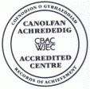

17th February 2017
21st Edition
November
End End

Another busy week at Shirenewton School ...

FOOTBALL TOURNAMENT

"Last Friday we played a football tournament. It was quite exciting going on the coach and travelling to the football tournament because there was good football spirit on the coach. We lost the first two matches but then we won the next few. Even though we didn't win the whole tournament itself, it was a lot of fun. Thank you to the people who organised it and to Mrs Humphreys and Mrs Brace and all guardians and parents who supported us. Mark was a big help and hopefully we'll get to go again."
By Juniper

CURRICULUM CYMRAEG WORKSHOPS
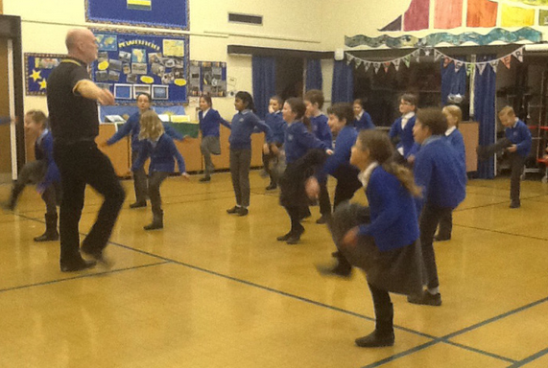

Huw Williams visited our school on Monday and ran Curriculum Cymraeg workshops for all the classes.
"We all went to the hall and listened to some Welsh traditional music played by all different instruments, for example the harp and tin whistle. We watched some dances and we tried them ourselves and did a whole dance through clog dancing. We learned quite a lot about the different traditional instruments they used to play in Wales for example we learned that the harp was played on the left shoulder and not the right. It was really good fun doing the clog dancing!"
By Rhianwen

DINOSAUR EXPERIENCE
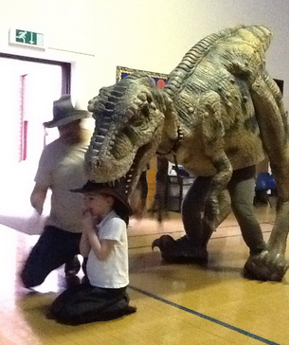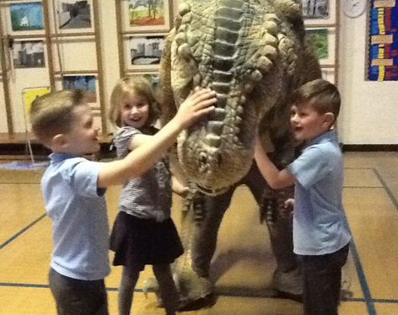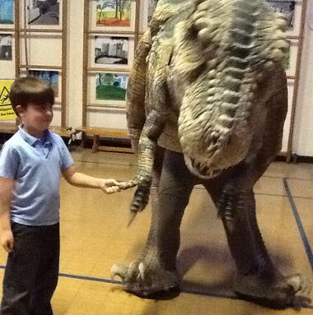
"The dinosaur came in and it was really exciting. It was a baby T-Rex and was 4 years old. Even though it was a baby it was very big! It was about 2 metres high and 4 metres long. We were allowed to stroke it on its nose. Natalie and Oscar knelt down and had a ranger's hat on and the dinosaur pulled it off their head and threw it at them and they caught it! He showed us some dinosaur teeth and they were as big as a banana. The egg was about 2 metres long. He asked us some questions and we had to guess what the dinosaur was and we guessed them all correct and then he showed us some videos about each dinosaur and they sang facts about them. I learned that the plates on their back helped them swim and were bigger than a dinner plate. Thank you to the PTA for paying for the dinosaur to come to school ... it was great!"
By Brereton & Faith

GILWERN
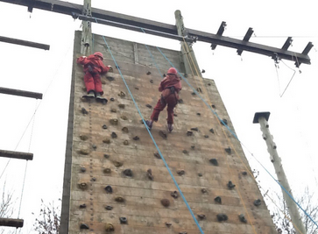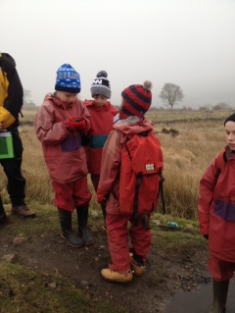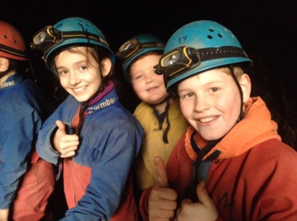
Can't wait to find out how Year 6 got on with the canoeing, caving, geocaching, hill walking and forest school activities at Gilwern this week when they return to school later today. I hear they had fun in the evenings too! Huge thank you to Mrs Graham, Mrs Eickhoff, Owen and all the other staff who gave up their time to ensure the children had a memorable experience.

RWI MODEL SCHOOL
Congratulations to all the Read Write Inc tutors in Foundation Phase who successfully retained our RWI Model School status for the 8th year running! This means we have frequent visitors from other schools who come and watch our lessons and in return RWI give us discounted resources. A special congratulations to Mrs Farley, our Reading Leader, who works tirelessly assessing and grouping the pupils, running masterclass training sessions and model lessons to ensure we remain top performers.

ST DAVID'S DAY
Leeks, made by School Council, are currently available for parents in the foyer for a donation to the British Heart Foundation. On St David's Day School Council will be selling a leek and a drink to pupils in all classes for a £1 donation to this charity.

Pupils have been working hard over the last couple of weeks entering various musical, artistic and written competitions ready for our Eisteddfod on Wednesday 1st March. On St David's Day pupils can come to school dressed in traditional Welsh costumes, Welsh rugby/football shirts, dressed as a miner/dragon/ daffodil etc or simply wear a plain red top.

CHANGE OF MENU
Don't forget, first week back after half term, there is a change of menu on the Tuesday and Wednesday. On Tuesday 28th February, the canteen will be cooking the roast dinner that was due to be served on the Wednesday. On the Wednesday they will cooking a special St David's day menu. This will consist of pork & leek sausages or Glamorgan sausage (veggie option) with creamed peas, potatoes and carrots OR lamb meatballs or vegetarian meatballs in tomato sauce with pasta. Dessert will be Welsh apple cake with vanilla ice-cream.

HEADTEACHER AWARDS
This week's head teacher certificates were awarded to:
Rec | Y1 | Y2 | Y3 | Y4 | Y5
Jack, Sophia & Noah | Iestyn, Tomos & Molly | Cally, Barney & Lauren | Jessica, Mali & Sienna | Enfys, Kate & Katie | Sam, Cailin & Bobby

GOLDEN TICKET WINNERS
Lucky golden tickets winners this week were:
By
Rec | Y1 | Y2 | Y3 | Y4 | Y5
Noah, Oliver & Jack | Milo B, Faith & Elisabeth | Isabel, Amelia & Aemilia | Phoebe, Evan F & Ethan H | Holly, Kate & Morgan | Joe, Walt & Isabella
Mrs Jill Mitchell
JillianMitchell@monmouthshire.gov.uk

PTA NEWS
1) School disco ... a big thank you to all who volunteered at the disco last Thursday, we had a great time!
2) Shirenewton Primary School Ladies Night - Friday, 3rd March, 2017. 7pm.
Don’t forget to buy your tickets for the ladies night ... clothes will be modelled by school children volunteers, the clothes will be high street fashion brands but will be up to 70% discounted prices on the night. Doors open at 7pm where there will be several stalls selling an array of items, plus some fully qualified beauticians doing mini manicures. Tea, coffee, soft drinks and cream cakes will be available to purchase, plus a licensed bar.
Take your seats at 7.30pm for a fashion show of ladies and children's clothes (modelled by students and volunteers from the school). The show lasts for about 45 minutes, after which you can browse the rails and make purchases. There will be over 1000 items of ladies and children’s clothing to suit all tastes, from top high street brands, with savings up to 50% and even 75% off original store prices. Sizes range from 8-22 for ladies and 2-14 years for children (boys and girls). All come with a 28 day full refund policy.
We will also be selling tickets for a raffle on the night, with the top prize being a £50 voucher to spend on clothes from the fashion show, plus other lovely prizes donated by our stall holders.
We will be selling tickets at £4 each or 3 tickets for £10. All adult tickets will include a glass of fizz (a non alcoholic option will also be available). Tickets available in advance from the school (01291 641774) or contact Shirenewton Primary School PTA via Facebook.
3) Don't forget you can leave an email address at r.dalton1976@outlook.com to be put on our list of volunteers.
4) The children will be performing for the Eisteddfod coffee morning on Friday 10th March so come along and give them your support.

SPRING TERM DATES
Please note: Any new dates are in red
For reminders, please download the Schoop app to your iPhone, iPad or Android device and enter our
school's unique ID - 10134
* * *  Mon 20th Feb to Fri 24th Feb - Half Term  * * *  Wed 1st Mar - St David's Day Eisteddfod  Fri 3rd Mar - Welsh Fortnight ends  Fri 3rd Mar - PTA Ladies Night  Mon 6th Mar - Y4 trip to Hilston Park  Mon 6th Mar - PTA meeting  Tue 7th Mar - Wildlife Quiz 1st Round (4 x Y6 pupils)  Wed 8th Mar - Parents Evening 4-7pm  Thur 9th Mar - KS2 Egyptian Museum Day 2.30pm (Y3-6 parents invited)  Thu 9th Mar - Parents Evening 4-7pm  Fri 10th Mar - Eisteddfod Coffee Morning 9.15am | Thu 16th Mar - Techniquest Workshops (at school):  - Rec - Y3 = Techniquest Maths Party  - Y3 - Y6 = Science Bright Sparks Experience  Tue 21st Mar - Wildlife Quiz 2nd Round  Fri 24th Mar - Red Nose day  Mon 27th Mar - Governors' Meeting  Fri 31st Mar - KS2 Enrichment Day  Tue 4th Apr - Y3 trip to Gilwern  Wed 5th Apr - Easter Assembly 9.30am - Y1 & Y4 parents are invited  Thu 6th Apr - PTA egg rolling  Fri 7th Apr - Readathon starts (more info to follow)  Fri 7th Apr - Last day of Spring Term  Mon 10th Apr to Fri 21st Apr - Easter Holiday

COMMUNITY CORNER
St David's Day Concert
St David's Day concert with The Singing Club and The Chepstow Chatelaines
Wednesday, 01 March 2017 - 7:30pm
The Drill Hall, Chepstow
Tickets £6 on the door
Songs, poetry & readings
BAR

Chepstow Museum
DROP-IN-AND-MAKE: Half Term Craft Session at
The Drill Hall, Lower Church Street, Chepstow
Thursdays February 16th & 23rd 2-4pm
AND
Clock our new clocks activity at the Museum

Chepstow Museum is running its popular drop in craft afternoon during the half term breaks on Thursdays February 16th and February 23rd from 2 until 4pm at the Drill Hall in Lower Church Street. They supply ideas, templates and materials and you bring your creativity to make your own special pieces! There are big tables to share with family and friends – so bring them along or arrange to meet up and spend an afternoon together making and being creative! Suitable for children of all ages, all children must be accompanied by an adult – up to three children per adult. Come for the whole afternoon or just pop in for a short time. A suggested donation towards the cost of materials and refreshments is £2 for children aged 3 +

This February half term you can find out all about clocks! Come and find our locally-made Chepstow clocks around the Museum, design your own clock face and earn your clockmakers badge! Our new clocks worksheet is available in English and Welsh. There are also lots of things to see and do at Chepstow Museum every day. Things to make, drawers to explore, costume to try on, games to play and quizzes and trails to do. And our touch screen interactives with our challenging salmon game to play. Come in and take a look!

