 “Learning Together, Achieving for Life”
Weekly Newsletter
www.shirenewton.monmouthshire.sch.uk NUT FREE SCHOOL

"Dysgu Gyda'n Gilydd, Cyflawni am Oes"

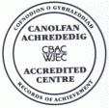

7th April 2017
27th Edition
November
End End

DINNER MONEY
Reminder: The cost of school meals have increased to £2.10 per day. All monies payable on a Monday or the first day of the school week, regardless of which day lunch is required. If you wish to pay for the term, the total cost for the summer term is £121.80. Cheques payable to Monmouthshire County Council or MCC.

DELVING INTO DINOSAURS
Here are Foundation Phase pupils proudly sharing their dinosaur learning with family members ...
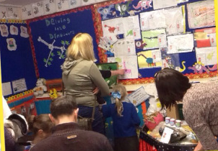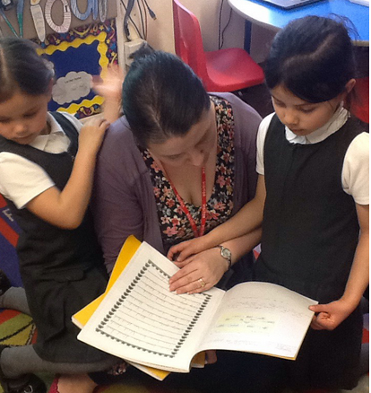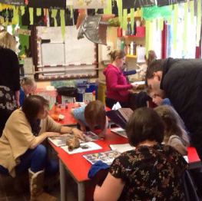
Thank you to Mrs Farley and the Foundation Phase team of staff for all their hard work in organising the event.
Y3 GILWERN TRIP
"On Tuesday we went to Gilwern Education Centre and we went to an inside climbing room. First we had to only use a certain colour hold for our hands and feet! Then we went out and did crate stacking - they would stack about 4 crates and 3 people got on and then you would have to slacken the rope, pull it forward and put it into this basket and then pull on rope to get up on to the next crate. On the last crate it was like Jenga ... they pulled some of the crates away and you were left dangling! It was fun. We also played circle games and at lunchtime when we were finished eating we could play rugby, football and skipping for 5 minutes. It was a fun and exciting trip and I'm looking forward to going again." By Albert

EASTER ACTIVITIES
Thank you to Year 1 and Year 4 pupils for sharing the Easter story with us in assembly this week and to our good friend Rev Waters for leading the prayers. Photos and videos of the assembly can be found on google drive: year4@shirenewtonprimary.co.uk
The children had fun competing in our yearly PTA egg rolling competition keenly watched over by the Easter Bunny! Thank you to the PTA for organising this event and providing the chocolate bunnies which were presented in assembly today. Photos of this event can be found on several of the class blogs on the school website.
Y5 ENTERPRISE PROJECT
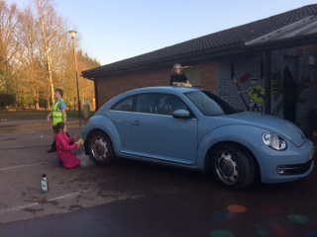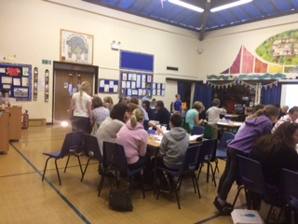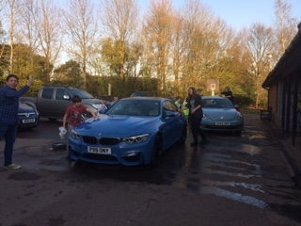
Year 5's enterprise project this term culminated in a fantastic fundraising evening yesterday with a fun family quiz, car washing, entertainments room (for non-quizzing children), raffle, soft drinks bar, tuck shop and a delicious fish & chip supper! The children organised absolutely EVERYTHING and in doing so covered a huge number of important learning and life skills from ALL areas of the curriculum. This is an example of just one of the ways our children have benefited from being in a Pioneer School (experimenting with new ways of learning whilst developing the new curriculum for Wales). Mrs Burbidge, who is our Lead Practitioner, deserves a special mention for all the hard work she has put in over the last few weeks making sure the children were on track to hold such an exciting and innovative event. Huge thank you also to Mrs Smith, Mrs Humphreys, Mrs Brace & Miss Brace who have supported the children in the build up to the event and helped ensure the smooth running of the evening. The children have just calculated they made a profit of £283.21.

KS2 ENRICHMENT
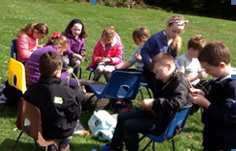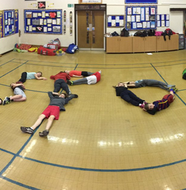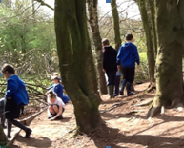
Junior Enrichment sessions that pupils could choose from this term were:
Scouting Experience – explored communication systems & sent each other messages using Morse code & radios
Culture Vultures - immersed themselves into all things Spanish, including learning the language, creating computer games and tasting tapas!
Outdoor Creators - made mud and clay sculptures on trees, dream catchers and picture frames using natural resources.
Arts & Crafts – made Easter activities including egg holders & bunny masks
Roving Reporters - took photos of the different activities and interviewed the children and staff. They then used this information to create i-Movies, Pic collages and newspaper reports.
Sports Stars – played football, netball, hockey, did team building and fun activities like hoola-hooping

KS 2 TRIP TO OGMORE
On the first day back after the Easter holiday the whole KS2 department are going on a trip to Ogmore as an immersion day for their summer term topic. Hopefully, the weather will be kind to them – please make sure the children are dressed appropriately according to the weather conditions on the day! They are allowed to bring up to £2 in case there is an ice-cream van nearby and of course will need a packed lunch with plenty of drinks.

READATHON
This Easter holiday you are invited to take part in a read-a-thon sponsored read fundraiser. Your child should have brought home information in case you would like then to take part ... a great way to encourage them to read over the holiday whilst raising funds for charity AND raising money to buy books for our school. Please can all sponsorship money be sent into school by 15th May. Happy reading!

MY-MATHS HOME LEARNING
Apologies, teachers haven't been able to access and set My Maths home learning recently as there have been technological problems! Hopefully, this will be rectified this week.

GYMNASTIC SUPER-STARS
Huge congratulations to Brereton, Molly and Laci in Year 1 who competed in a recent Gymnastics competition ...

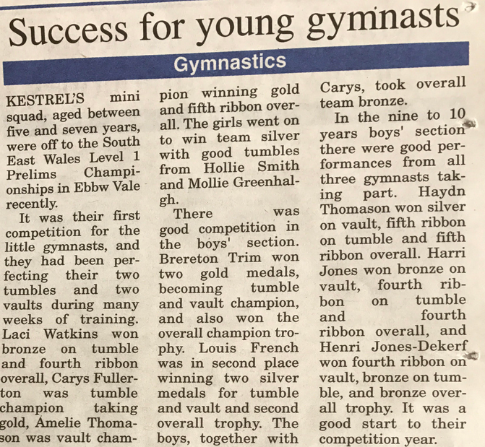

HEADTEACHER AWARDS
Last week's head teacher certificates were awarded to:
Rec | Y1 | Y2 | Y3 | Y4 | Y5 | Y6
Daisy, Jack & Hugo | Miley, Milo B & George | Amelia, Owen & Oliver | Lowri, Phoebe & Henry | Roshan, Oliver & All Year 4 | Bobby, Archie & Isabella | James, Daniel & Sorcha

SUMMER TERM CLUBS
Here are the lunchtime and after school clubs we will be offering in the summer term. More info on teacher-led clubs will follow next term; please contact Mrs Saysell if you would like to enrol your child in a club led by an outside provider.
CLUB | DAY | TIME | YEAR GROUP | ORGANISER | COST
Gardening | Monday | Lunchtime | Rec, Y1, Y2 | Mr Ledville-Smith | Free
Multi-sports | Monday | 3.30-4.30 | Rec, Y1, Y2 | Attribute Sports | £30
Minecraft | Mondays | 3.30-4.30 | Y2 – Y6 | Mi Little Pad | £39.90
Country Dancing | Tuesday | Lunchtime | Y1, Y2, Y3, Y4 | Mrs H Stephens | Free
French | Wednesday | Lunchtime | Rec, Y1, Y2 | Club Bonjour | £25
Chess | Wednesday | Lunchtime | Y2 - Y6 | Mr Stevenson | tbc
KS2 Choir | Wednesday | Lunchtime | Y3 – Y6 | Mrs Buchan | Free
Minecraft | Wednesday | 3.30-4.30 | Y2 – Y6 | Mi Little Pad | £47.88
Book Club | Thursday | Lunchtime | Rec, Y1, Y2 | Mrs Farley & Mrs Humphreys | Free
French | Thursday | 3.30-4.30 | Y3 – Y6 | Club Bonjour | £35
Lacrosse | Friday | Lunchtime | Y3 – Y6 | Sports Council & Mrs Burbidge | Free
Art Club | Friday | Lunchtime | Y1 & Y2 | Mrs Farley & Miss Whyte | Free
Multi-sports | Friday | 3.30-4.30 | Y3 – Y6 | Attribute Sports | £36
In addition, we have our After School Club run by Melinda Phillips every day.

By
Mrs Jill Mitchell
JillianMitchell@monmouthshire.gov.uk

PTA NEWS
PTA updates ...
- Start gathering your unwanted good quality clothing for our "rags 2 riches" collection on Wednesday 3rd May to raise extra funds for the school.
- Don't forget the family fun bingo and fish and chips night will be on Friday 5th May, so save the date!
- The next school disco will be Thursday 25th May.

SUMMER TERM
For reminders, please download the Schoop app to your iPhone, iPad or Android device and enter our
school's unique ID - 10134
New additions in red to help you spot them!
Mon 24th Apr - Back to school  Mon 24th Apr - KS2 trip to beach  Tue 25th Apr - Y1 Forest School  Wed 26th Apr - Y3 & Y4 Outdoor learning project  Fri 28th Apr - Y2, Y3 & Y4 ballet & museum trip  Mon 1st May - May Day  Tues 2nd May - Y1 Forest School  Wed 3rd May to Wed 10th May - National Tests for Y2 - Y6 (No holidays authorised during this week)  Wed 3rd May - Y3 & Y4 Outdoor learning project  Wed 3rd May - Reception Parents Evening 4-7pm  Wed 3rd May - PTA Rags 2 Riches collection  Thu 4th May - FP Enrichment Afternoon  Thu 4th May - Reception Parents Evening 4-7pm  Fri 5th May - PTA Family Bingo Fun and fish and chips night!  Mon 8th May - PTA meeting 6.30pm in school - all parents are welcome to attend  Tue 9th May - Y1 Forest School  Wed 10th May - Y5 Kwik Cricket Festival, Caldicot Castle  Wed 10th May - Y3 & Y4 Outdoor learning project  Thu 11th May - FP Enrichment Afternoon  Mon 15th May - Read-a-thon money in  Tue 16th May - Y1 Forest School  Thu 18th May - FP Enrichment Afternoon  Fri 19th May - Wheelchair sports for Rec & Y1 - Y4  Mon 22nd May - Y2 Forest School  Mon 22nd May - Reception & Y6 class photos  Tue 23rd May - Y1 Camp Fire  Thu 25th May - FP Enrichment Afternoon  Thu 25th May - PTA Discos  * * *  Mon 29th May to Fri 2nd Jun - Half Term  * * * | Mon 5th Jun - Y2 Forest School  Wed 7th Jun - WAG Education Officer visiting School Council  Fri 9th Jun - Sports Day (KS2 at 9.15am & FP at 1.45pm)  Mon 12th Jun - Growth & Vision tests for Reception  Mon 12th Jun - Y2 Forest School  Wed 14th Jun - Reserve Sports Day  Wed 14th Jun - New Reception parents meeting 6pm  Sat 17th Jun - PTA Summer Fayre 11am-2pm  Mon 19th Jun - Governors' AGM Meeting (inc Sports Council presentation)  Mon 19th Jun - Y2 Forest School  Wed 21st Jun - School Council trip to Senedd, Cardiff Bay  Fri 23rd Jun - Reserve, Reserve Sports Day  Mon 3rd Jul - INSET (Self Evaluation with Govs)  Mon 3rd July to Friday 14th July - Transition Fortnight  Thu 6th Jul - Fire Safety talk for Y4 - Y6  Fri 7th Jul - Le Grande Pique-Nique at Chepstow Castle for Y6  Fri 7th Jul - Reports to go home  Fri 7th Jul - Hog Roast  Mon 10th Jul - Pupil Committee Elections  Tue 11th Jul - New Reception visit pm & lunch  Wed 12th Jul - Open Afternoon 2pm  Wed 12th Jul - Parents Evening for those that request it 4pm - 5.30pm  Wed 12th Jul - Music Event 6pm  Thu 13th Jul - New Reception visit pm & lunch  Wed 19th Jul - Y2 Graduation (Y2 parents) 9.30am  Thur 20th Jul - Y6 Leavers' Assembly  Fri 21st Jul - Last day of academic year
ADVANCE NOTICE 2017/18
Mon 4th Sept - INSET Day
Tues 5th Sept - Back to school for pupils
Fri 27th Oct - INSET Day
Mon 30th Oct to Fri 3rd Nov - Half term
Fri 22nd Dec - Last day term
Mon 25th Dec to Fri 5th Jan - Christmas holiday
Mon 8th Jan - Back to school
Mon 19th Feb to Fri 23rd Feb - Half term
Thu 29th Mar - Last day
Fri 30th Mar to Fri 13th Apr - Easter holiday
Mon 16th Apr - Back to school
Mon 7th May - May Day
Mon 28th to Fri 1st Jun - Half trem
Tue 24th Jul - Last day

COMMUNITY CORNER
