 “Learning Together, Achieving for Life”
Weekly Newsletter
www.shirenewton.monmouthshire.sch.uk NUT FREE SCHOOL

"Dysgu Gyda'n Gilydd, Cyflawni am Oes"

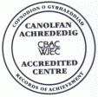

12th May 2017
30th Edition
November
End End


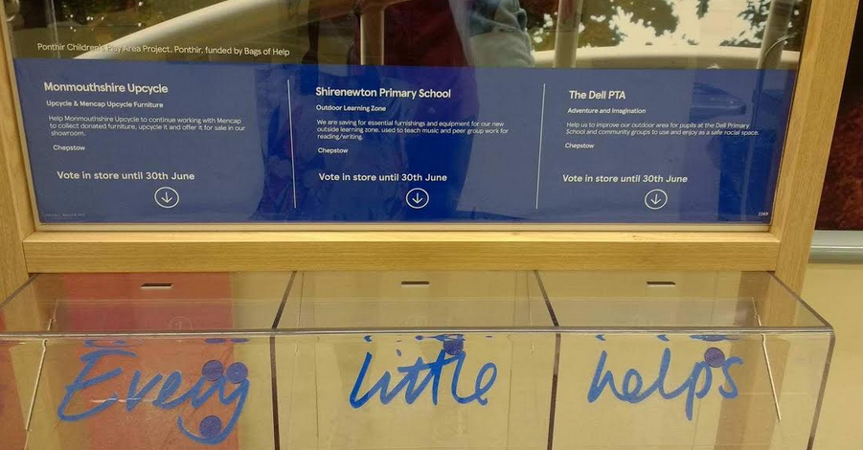
"Bags of Help" is Tesco’s exciting local community grant scheme where the money raised from the 5p bag charge is being used to fund thousands of local projects in communities right across the UK. Customers are given a token when they buy their shopping that they can use to make their choice using the voting units. Online customers can take their Customer Delivery Note into store and show this to a colleague in order to be given a voting token. For the months of May and June, Shirenewton is up against The Dell PTA and Monmouthshire Upcycle! The project with the most votes will receive a grant of up to £4,000; second place receiving up to £2,000 and third place up to £1,000.
Please encourage everyone you know who shops in Tesco to vote for us!!

Y5 SWIMMING
Y5 will be doing a 'water safety' session in their swimming lesson on Monday so they will need shorts and a t-shirt in addition to their costume and towel (no goggles needed).

SAINSBURYS VOUCHERS
If you have any Sainsburys vouchers at home ... please send them in school by Friday 19th May. Diolch!

READ-A-THON
Well done to everyone who completed their Read-a-thon challenge ... please send in sponsor money as soon as you can.

DESIGN-A-STAMP COMPETITION

We are very excited and proud that Archie Allen is an area finalist in the Royal Mail design a stamp competition. In his age group he is one of only five pupils from the whole of Wales selected! This is an excellent achievement, as Royal Mail received and judged over 205,000 entries! During the next month, a panel of judges will select the winners from the 120 area finalists, and then a VIP judging panel will choose the two overall winners. Being a finalist Archie has won £100 in vouchers for himself and £100 for the school. Huge congratulations Archie!

ATTENDANCE HEROes
Classes who had an attendance rate above our target of 96.5% in the Spring term were:
Year 3 - 98.23% Year 6 - 96.8% Year 2 - 96.75%
They will be voting on their class reward today! (Please note: attendance rates of pupils with a medical statement and those on reduced timetables are not included in these calculations)

Y5 KWIK CRICKET FESTIVAL

What a beautiful setting and weather the Y5 cricket team had on Wednesday for the cricket festival organised in conjunction with Sudbrook Cricket Club. Their club coach will be visiting school on Tuesday before half term to do a cricket taster session with Y3.
"Today 10 members of year 5 took part in a fabulous inter school cricket tournament in the grounds of Caldicot castle. We had a fabulous time , winning 2 games out of 3. We might get through to the next round and are excited to find out where we came out of all the schools who took part. Mrs Graham even learnt how to accurately score a game from an expert!!!"

Y6 DRAGON'S DEN
We now have the dates of the Dragon's Den project that runs at Chepstow School every year for six MAT (more able and talented) pupils from Y6 (please see calendar dates below). They will be working with two MAT pupils from Chepstow to form a team of eight. This year the aim is to encourage pupils to investigate and apply the way that changing technology may be used to assist in human healthcare. They will be developing one idea which will improve living standards for a target population. Their parents are invited to watch them pitch their idea to a panel of 'Dragons' in the evening of Thursday 8th June, 5.30-7pm.

SUMMER FAYRE

HEADTEACHER AWARDS
This week's head teacher certificates were awarded to:
Rec | Y1 | Y2 | Y3 | Y4 | Y5 | Y6
Tommy,  Evie D & Hugo | Martha GL, James & Gracie | George G, Terah & Chloe | Ella R, Albert & Ben | Emily, Harry & Matilda | Archie, Rhianwen & Joe | Arran, Imogen T & Pippa

By
Mrs Jill Mitchell
JillianMitchell@monmouthshire.gov.uk

PTA NEWS
PTA updates ...
- Well done Easter egg rollers, you raised £150 for the school!
- Thank you to everyone who donated to our ‘rags to riches’ we raised £81 for the school!
- A huge thanks to all who took part in the first ever Shirenewton School Bingo Night, it was great fun and we raised £200 for the school!
- If you, your friends or family, shop in Chepstow or Bulwark TESCO, please put your blue coin into the slot for Shirenewton School and we could win up to £4000 for the school!!!
Dates to remember
- School disco Thursday 25th May. Disco 3:30 to 4:30 foundation phase 4:45 to 5:45 KS2. £2.50 per child, £5 per family. Squash and biscuits included.
- School cinema showing of Moana Thursday 8th June. 3.30- 5.00, £2.50 per child, £5 family. Free juice and popcorn.
- Saturday 17th June...SUMMER FETE and VILLAGE MARKET 11am-2pm

SUMMER TERM
Additions and changes are in red
Tue 16th May - Y1 Forest School  Tue 16th May - Y3 & Y4 Outdoor project  Wed 17th May - Reception Forest School  Thu 18th May - FP Enrichment Afternoon  Thu 18th May - Y3 & Y4 Outdoor project  Fri 19th May - Wheelchair sports for Rec & Y1 - Y4  Mon 22nd May - Y2 Forest School  Mon 22nd May - Reception & Y6 photos  Tue 23rd May - Y1 Camp Fire  Tue 23rd May - Cricket taster session for Y3  Tue 23rd May - Y3 & Y4 Outdoor project  Wed 24th May - Reception Forest School  Thu 25th May - FP Enrichment Afternoon  Thu 25th May - Y3 & Y4 Outdoor project  Thu 25th May - PTA Discos  * * *  Mon 29th May to Fri 2nd Jun - Half Term  * * *  Mon 5th Jun - Y2 Forest School  Mon 5th Jun - PTA Meeting 6.30pm  Tue 6th Jun - Y3 & Y4 Outdoor project  Wed 7th Jun - WAG Education Officer visiting School Council  Wed 7th Jun - Reception Forest School  Wed 7th Jun - Dragon's Den project at Chepstow School all day (6 x Y6 pupils)  Thu 8th Jun - Y3 & Y4 Outdoor project  Thu 8th Jun - PTA Cinema Evening 3.30-5.00pm  Thu 8th Jun - Dragon's Den project at Chepstow School in afternoon & parents invited 5.30-7pm  Fri 9th Jun - Sports Day (KS2 at 9.15am & FP at 1.45pm)  Mon 12th Jun - Growth & Vision tests for Reception  Mon 12th Jun - Y2 Forest School  Tue 13th Jun - Y3 & Y4 Outdoor project | Wed 14th Jun - Reserve Sports Day  Wed 14th Jun - New Reception parents meeting 6pm  Thu 15th Jun - Y3 & Y4 Outdoor project  Sat 17th Jun - PTA Summer Fayre & Village Market 11am-2pm  Mon 19th Jun - Governors' AGM Meeting (inc Sports Council presentation)  Mon 19th Jun - Y2 Forest School  Tue 20th Jun - Y3 & Y4 Outdoor project  Wed 21st Jun - School Council trip to Senedd, Cardiff Bay  Thu 22nd Jun - Y3 & Y4 Outdoor project  Fri 23rd Jun - Reserve, Reserve Sports Day  Tue 27th Jun - Y3 & Y4 Outdoor project  Wed 28th Jun - Y5 invited to Chepstow School to see 'Matilda'  Thu 29th Jun - Y3 & Y4 Outdoor project  Mon 3rd Jul - INSET (Self Evaluation with Govs)  Mon 3rd July to Wed 12th July - Chepstow School Transition for Y6  Tue 4th Jul - Y3 & Y4 Outdoor project  Thu 6th Jul - Fire Safety talk for Y4 - Y6  Thu 6th Jul - Y3 & Y4 Outdoor project  Fri 7th Jul - Le Grand Pique-Nique at Chepstow Castle for Y6  Fri 7th Jul - Reports to go home  Fri 7th Jul - Hog Roast  Mon 10th Jul - Pupil Committee Elections  Tue 11th Jul - New Reception visit pm & lunch  Wed 12th July - Y6 Chepstow School concert  Thu 13th Jul - New Reception visit pm & lunch  Wed 19th Jul - Y2 Graduation (Y2 parents) 9.30am  Thu 20th Jul - Y6 Leavers' Assembly  Fri 21st Jul - Last day of academic year

COMMUNITY CORNER
Countdown to the best Devauden Festival yet..........

Following the success of Devauden Races at the start of May the team in Devauden are now making their final preparations for what promises to be the biggest and best Devauden Festival yet.

Taking place Friday 12 and Saturday 13 May, this year's festival has something to offer festival goers of all ages.

Taking pride of place will be a new, improved creative Kids Zone, guaranteed to keep the younger festival goer amused and entertained. Judy Wasdell (festival organiser) said “Come and try your hand at one of the music, percussion, creative workshops or yoga sessions and be prepared to be amazed with our resident contact juggler and fire artist Truan Jay Mathias”

This eighth edition of the festival will also feature a Big Top Tent which will hold the main and second stages with a third acoustic stage on site to cater for over 30 live acts over the two days. With Monmouthshire’s very own Rusty Shackle headlining on the Saturday night.

Festival organiser Judy added “The team are very excited about this year’s festival, We believe it’s the best line-up in the eight year history of the festival and with the big top, workshops, stalls, kids activities and range of food and drink on offer we're really looking forward to a great weekend of family fun.”

With a licensed bar, a variety of food stalls, arts and craft stands and wall to wall great music there is something for everyone at this family friendly event in a great village location with outstanding views.

For details of the full line up and how to purchase tickets visit www.devaudenfestival.com.

