 “Learning Together, Achieving for Life”
Weekly Newsletter
www.shirenewton.monmouthshire.sch.uk NUT FREE SCHOOL

"Dysgu Gyda'n Gilydd, Cyflawni am Oes"

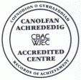

24th March 2017
25th Edition
November
End End

DELVE INTO DINOSAURS
Following the huge success of our recent Ancient Egyptian museum afternoon, Foundation Phase parents are invited into school at 2.30pm on Friday 31st March so the pupils in Reception, Year 1 and Year 2 can share all the learning they have been doing this term about dinosaurs.

TOOTY-FRUITY DAY
To promote healthy eating and encourage pupils to try new fruits our Healthy Schools Committee are currently planning an 'unusual fruits' tasting day! On Friday 28th April, they are kindly asking for some donations of unusual fruits per family. The tasting will take place during an extended break for KS2 pupils, and for FP pupils, the Healthy Schools Committee will bring the fruit round to the classes and explain about each fruit.

DEFIBRILLATOR

As many of you will remember Laura Saysell, one of our school governors, ran the London Marathon last year and raised enough money to buy the school a defibrillator. This week all staff received training on resuscitation techniques and were shown how to use the defibrillator. Our defib is now situated just inside the main entrance doors to the school; we hope we will never have to use it but it is very reassuring to know we have one just in case!

BRILLIANT BLOGGING
We hope you are regularly accessing the class blogs on our website - a great way to find out about some of the things the children have been doing each week (especially useful if you have a child who comes home and says they haven't done anything!) Thank you to the staff and indeed the children who regularly blog to help keep you updated!
www.shirenewtonprimary.monmouthshire.sch.uk

PTA RAFFLE PRIZES
Paula Rimmer (mother of George in Y2) does a fantastic job each year in securing donations for our Summer Fayre raffle. Two of our supporters this year are Chepstow Racecourse and The National Botanical Garden of Wales - please see the 'community corner' at the end of this newsletter for some exciting ideas for days out with the family. If any of you have contacts with companies that you think would like to donate a raffle prize, please see Paula or any PTA committee member.

AWESOME ATTENDANCE
When discussing attendance with a group of pupils this week, they reported they find missing school stressful as when they return to school they must learn what they've missed, and also learn what is being taught that day!

SCHOOL DINNERS
A new Summer menu is starting after the Easter Holidays, please note the week commencing the 3rd April will be week 2’s menu choices on the current Winter menu. Reminder: Monmouthshire County Council are charging £2.10 for a school dinner, starting 1st April.

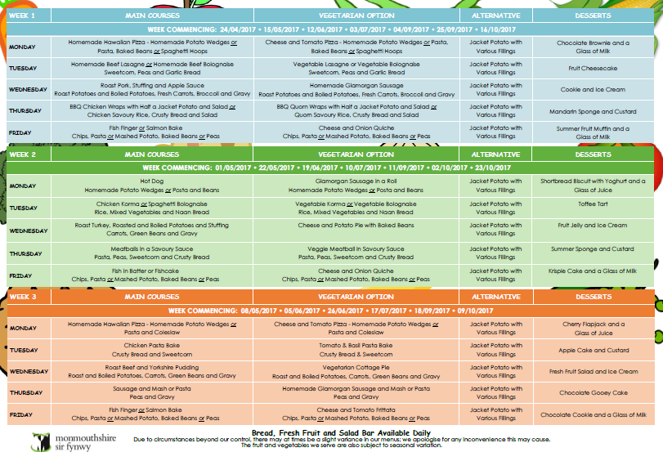

HEADTEACHER AWARDS
This week's head teacher certificates were awarded to:
Rec | Y1 | Y2 | Y3 | Y4 | Y5 | Y6
Tommy, Emi & Evie D | Amélie, Annabel & Brereton | Demi, Jude & Ella | Grace, Evie & Joshua D | Eleanor, Morgan & Charlotte | Cailin, Issy & Walt | Ben, Alex & Grace

By
Mrs Jill Mitchell
JillianMitchell@monmouthshire.gov.uk

PTA NEWS
PTA dates for your diary:
Wednesday 5th April - Easter Assembly for parents of year 1 and 4. Refreshments will be available from the PTA from 9am with assembly starting at 9.30am
Thursday 6th April - Egg Rolling Tournament ... decorated hard boiled chicken eggs only!! Plus £1 to enter
Friday 5th May - Family Bingo Fun and fish and chips night! Food order forms will be sent out prior to the event

REMAINING SPRING TERM DATES
Please note: Any new dates are in red
For reminders, please download the Schoop app to your iPhone, iPad or Android device and enter our
school's unique ID - 10134
Mon 27th Mar - Tag Rugby Tournament at The Dell 1pm  Mon 27th Mar - Governors' Meeting with Healthy Schools Committee doing a presentation  Fri 31st Mar - Delve into dinosaurs with your FP children - Rec, Y1 & Y2 parents invited into classes 2.30pm  Fri 31st Mar - KS2 Enrichment Day  Tue 4th Apr - Y3 trip to Gilwern | Wed 5th Apr - Easter Assembly 9.30am - Y1 & Y4 parents are invited  Thu 6th Apr - PTA egg rolling  Thu 6th Apr - Y5 enterprise event - quiz & car wash  Fri 7th Apr - Readathon starts (more info to follow)  Fri 7th Apr - Last day of Spring Term  Mon 10th Apr to Fri 21st Apr - Easter Holiday

COMMUNITY CORNER
Magor Marsh
Spring Fun Day – Saturday 8th April 1-4pm at Magor Marsh NP26 3DD. Children £2. Adults FREE. Pond Dipping, bird watching and springtime crafts.
Marshy Monday – 10th April 1-3pm. Children £2. Adults FREE. Join Petra for some pond dipping and wildlife exploration

Chepstow Racecourse invite you to the NSPCC Big Family Fun Raceday on Monday 17th April ...


The National Botanical Garden of Wales have many exciting events planned for visitors this Spring ...
