 “Learning Together, Achieving for Life”
Weekly Newsletter
www.shirenewton.monmouthshire.sch.uk NUT FREE SCHOOL

"Dysgu Gyda'n Gilydd, Cyflawni am Oes"

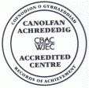

5th May 2017
29th Edition
November
End End

Y2, Y3, Y4 TRIP

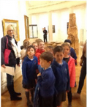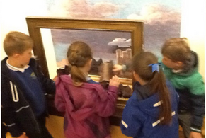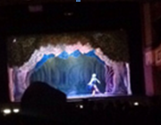
Year 2, Year 3 and Year 4 classes were treated to a free trip last Friday to Cardiff Museum and the theatre to watch a 'Goldilocks' ballet - courtesy of an Arts Council of Wales 'Go and See' grant. This scheme funds visits to high quality arts events in galleries and theatres and is one of the ways the Arts Council is trying to ensure the arts are central to the life and well being of the nation! A good time was had by all!

SWIMMING LESSONS
Remaining swimming lessons on Mondays this term:
Year 5 - 8th May, 15th May, 22nd May, 10th July - cost £8
Year 6 - 5th June, 12th June, 19th June, 26th June, 17th July - cost £10

FIDGET SPINNERS
The latest craze at the moment seems to be 'Fidget Spinners' - whilst we are happy to allow children to play with them at playtime they are NOT ALLOWED IN LESSONS! They need to be kept in bags in the cloakroom and not enter the classrooms at all ... otherwise they will be confiscated!

CHANGE OF DATES
PLEASE NOTE: We have heard this week that Chepstow School have shortened their transition fortnight by two days!! Year 6 pupils going to this secondary school will now spend their last day there on Wednesday 12th July and will return to Shirenewton on Thursday 13th July. Year 6 parents are invited to see their children perform in a concert at Chepstow School on the evening of Wed 12th (time tbc). This obviously has a knock-on effect to our own music event that we had previously planned for Wednesday 12th July ... change of date to follow, watch this space!

SLOW DOWN!!
Please show consideration to villagers walking and other road users when driving through the village.
I have had complaints about parents speeding through Mynyddbach and Weyloed Lane.

ENRICHMENT SESSIONS
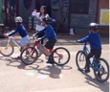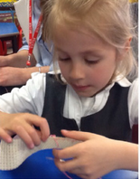
On Thursday afternoons this half term Foundation Phase children are enjoying their final set of enrichment sessions for the year ... Glorious Gardeners, Serious Sewing, Cycling Safety, Master Chef, Music Band, Orienteering, Animation & Mad Scientists!

HEALTHY SCHOOLS COMPETITION
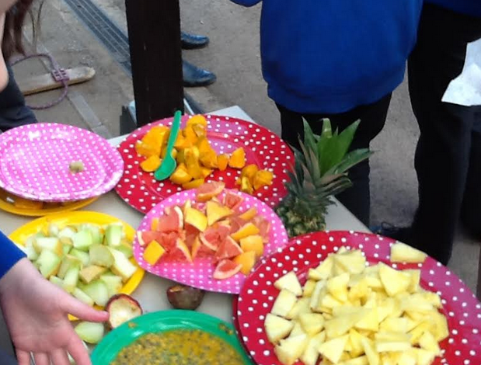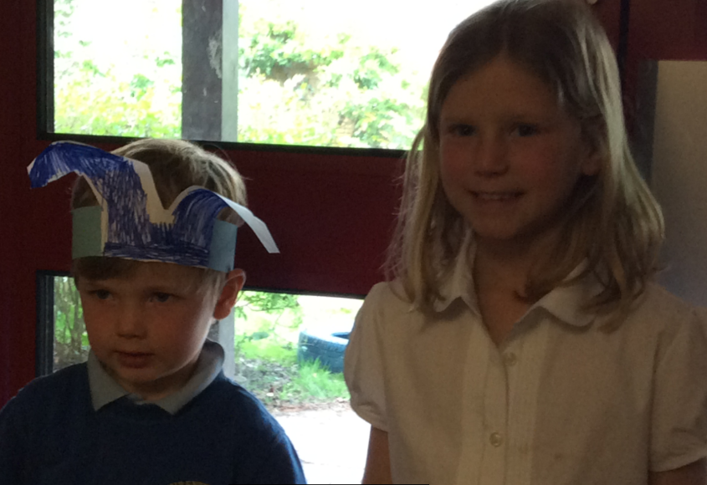
Thank you to Mrs Burgham and the Healthy Schools committee for the 'Tooty Fruity' day activities:
"Over the holidays everyone had a choice if they wanted to make a collage out of fruit and to take a photo and bring it in to school for healthy schools to select a winner. The Healthy School committee chose Evie Kopp in Year 3 and Llewi Evans in Reception as the two winners. They were presented with a hamper of fruit each in assembly."
Written by Anjali and Reuben

ECO COMPETITION
Thank you to Mrs Buchan and the Eco committee for organising 'The Big Battery' and all the pupils who collected so many batteries. Congratulations to Llewi Evans in Reception class who collected the highest number of batteries as an individual. Here are some comments from some of the entrants about why recycling batteries is important.
Frankie (Y4): "If we keep doing it we will help to save the planet. Also it is important that we recycle valuable resources."
Joshua (Y3) & James (Rec): "We had a bucket of old batteries in the garage and mum wanted to recycle them. This means less batteries in landfill and less clutter in the garage!!"
Alfie (Y5), Matilda (Y4) & George (Y1): "It’s a good feeling to save the environment."
Amelia: "It keeps them out of landfill sites where heavy metals may leak causing soil and water pollution."
By running this competition they saved 1184 batteries from going to landfill – bendigedig blant!

RAGS TO RICHES
Thank you to everyone who supported the PTA by donating unwanted clothing - we collected 48 bags weighing 204.3 kg which raised £81.72

ART CLUB
In addition to the clubs listed in last week’s newsletter … Mrs Graham will be running an Art Club for Y5 & Y6 on Tuesday lunchtimes.

HEADTEACHER AWARDS
This week's head teacher certificates were awarded to:
Rec | Y1 | Y2 | Y3 | Y4 | Y5 | Y6
Sienna, Jessie R & Sam | Iestyn, Annabel & Arjun | Floelyn, Barney & Lyla | Reuben, Juniper & Caitlin | Sebastien, Oscar N & Cai | Lily,  Paige  & George | James, Brynn & George
By
Mrs Jill Mitchell
JillianMitchell@monmouthshire.gov.uk

SUMMER TERM
Additions and changes are in red, so easily identified!!
Mon 8th May - PTA meeting 6.30pm in school - all parents are welcome to attend  Tue 9th May - National Reasoning Test for Y6  Tue 9th May - Y1 Forest School  Tue 9th May - Y3 & Y4 Outdoor project  Wed 10th May - Y5 Kwik Cricket Festival, Caldicot Castle  Wed 10th May - Y4 Forest School  Thu 11th May - FP Enrichment Afternoon  Thu 11th May - Y3 & Y4 Outdoor project  Fri 15th May - Read-a-thon ends  Tue 16th May - Y1 Forest School  Tue 16th May - Y3 & Y4 Outdoor project  Thu 18th May - FP Enrichment Afternoon  Thu 18th May - Y3 & Y4 Outdoor project  Fri 19th May - Wheelchair sports for Rec & Y1 - Y4  Mon 22nd May - Y2 Forest School  Mon 22nd May - Reception & Y6 photos  Tue 23rd May - Y1 Camp Fire  Tue 23rd May - Y3 & Y4 Outdoor project  Thu 25th May - FP Enrichment Afternoon  Thu 25th May - Y3 & Y4 Outdoor project  Thu 25th May - PTA Discos  * * *  Mon 29th May to Fri 2nd Jun - Half Term  * * *  Mon 5th Jun - Y2 Forest School  Tue 6th Jun - Y3 & Y4 Outdoor project  Wed 7th Jun - WAG Education Officer visiting School Council  Thu 8th Jun - Y3 & Y4 Outdoor project  Fri 9th Jun - Sports Day (KS2 at 9.15am & FP at 1.45pm)  Mon 12th Jun - Growth & Vision tests for Reception  Mon 12th Jun - Y2 Forest School | Tue 13th Jun - Y3 & Y4 Outdoor project  Wed 14th Jun - Reserve Sports Day  Wed 14th Jun - New Reception parents meeting 6pm  Thu 15th Jun - Y3 & Y4 Outdoor project  Sat 17th Jun - PTA Summer Fayre  Mon 19th Jun - Governors' AGM Meeting (inc Sports Council presentation)  Mon 19th Jun - Y2 Forest School  Tue 20th Jun - Y3 & Y4 Outdoor project  Wed 21st Jun - School Council trip to Senedd, Cardiff Bay  Thu 22nd Jun - Y3 & Y4 Outdoor project  Fri 23rd Jun - Reserve, Reserve Sports Day  Tue 27th Jun - Y3 & Y4 Outdoor project  Wed 28th Jun - Y5 invited to Chepstow School to see 'Matilda'  Thu 29th Jun - Y3 & Y4 Outdoor project  Mon 3rd Jul - INSET (Self Evaluation with Govs)  Mon 3rd July to Wed 12th July - Chepstow School Transition for Y6  Tue 4th Jul - Y3 & Y4 Outdoor project  Thu 6th Jul - Fire Safety talk for Y4 - Y6  Thu 6th Jul - Y3 & Y4 Outdoor project  Fri 7th Jul - Le Grand Pique-Nique at Chepstow Castle for Y6  Fri 7th Jul - Reports to go home  Fri 7th Jul - Hog Roast  Mon 10th Jul - Pupil Committee Elections  Tue 11th Jul - New Reception visit pm & lunch  Wed 12th July - Y6 Chepstow School concert  Tbc – Music Event, optional parents’ evenings & open afternoon  Thu 13th Jul - New Reception visit pm & lunch  Wed 19th Jul - Y2 Graduation (Y2 parents) 9.30am  Thu 20th Jul - Y6 Leavers' Assembly  Fri 21st Jul - Last day of academic year

