 “Learning Together, Achieving for Life”
Weekly Newsletter
www.shirenewton.monmouthshire.sch.uk NUT FREE SCHOOL

"Dysgu Gyda'n Gilydd, Cyflawni am Oes"

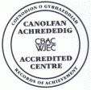

10th March 2017
23rd Edition
November
End End

Another action-packed week at Shirenewton ...
CHOIR
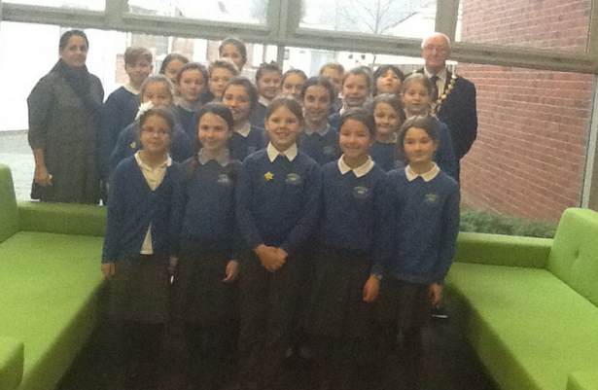
"Last Friday the Junior Choir went to Usk County Hall to entertain some important people who were attending a special RE meeting. We sang three songs when they were drinking coffee - The Chocolate Song, Everywhere Around Me, and Wouldn't It Be Funny? We got to sing our favourite chocolate song twice! Cantref school were there singing too - we saw some of our school work which was on display. We got a biscuit as a thank you gift. Thank you to Mrs Buchan for helping us practice and for taking us there." By Rhianwen

YEAR 4 TRIP
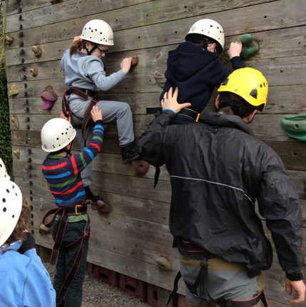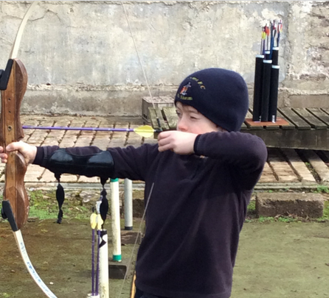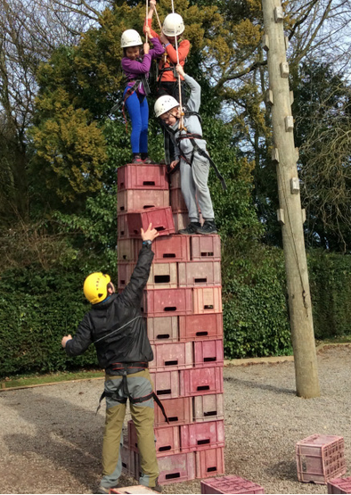
"On Monday we went to Hilston Park, it was really fun! The activities we did were archery, crate stacking, traversing, team building and problem solving. We started with a warm up game so the leaders (Ric, Richard & Tom) could get to know our names. Crate stacking was our favourite activity - two people had to hold the ropes to make sure you didn't fall ... you really had to trust them! When it was 11 crates high they started playing Jenga and pulling the crates out. It was a bit scary when the crates fell because you were left there dangling for a while! Emily: my second favourite activity was traversing because I like climbing and the challenge was to use the least amount of holds as possible.
Roshan: my second favourite thing was archery because we used real bows and the arrows were really pointy. My arrow hit a gold one in the middle! In conclusion, we thought our trip was spectacular!"
Thank you to Mrs Buchan, Mrs Brace and Mrs Kingman for giving them such a memorable experience.
By Roshan & Emily
FOOTBALL TALENT
Congratulations to Henry (Year 3) whose goalkeeping career continues to go from strength to strength. After being selected for Cardiff City Football Academy's prep squad he has played away games at Birmingham City, Chelsea FC, West Bromwich Albion and Reading. Well done Henry, we are very proud of your achievements.

WILDLIFE QUIZ
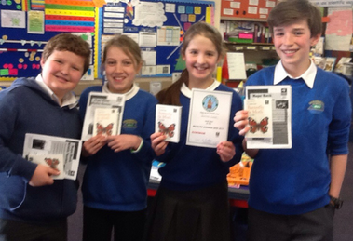
"On Tuesday Sam, Seren J, Arran and I went to Chepstow School to compete in the wildlife quiz organised by Magor Marsh. We came second by only 2 points! It was really close and nearly a draw! There was this partner question 'Which 2 animals can fly?' There were 4 options - ragged robin, squirrel, bat and a beetle - Arran knew the answer but accidently said the wrong one! We didn't mind not winning because it was fun doing it and we learned more about the wildlife in Britain at the same time. When we got back to school we found out Mrs Graham's daughter was in the winning team!"
Thank you to Mrs Humphreys for accompanying them.
By Jemima

YEAR 2's SPECIAL RE VISITOR
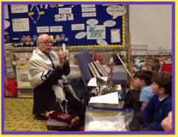
Yaakov visited Y2's RE lesson this week to talk to them about the Jewish festival of Purim. He answered all their questions and told them lots of interesting facts. He also bought some Jewish artefacts with him. The children thoroughly enjoyed his visit and Yaakov was very complimentary about their good manners and behaviour and their knowledge about a wide range of religions! Thank you to Mrs Farley for arranging this experience.

EGYPTIAN MUSEUM DAY
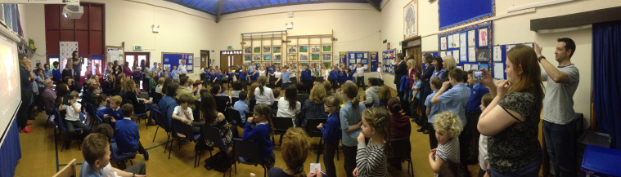
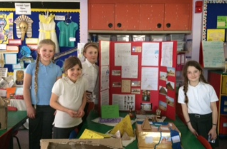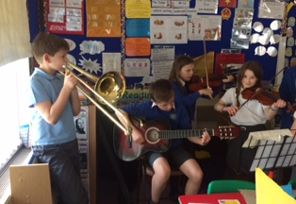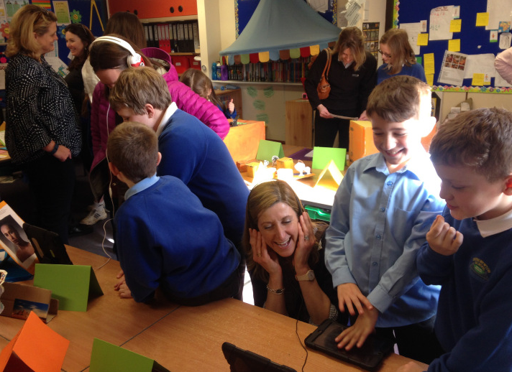
KS2 classes were transformed into museums yesterday afternoon as the pupils exhibited all the excellent Ancient Egyptian learning they have produced this term. This was a truly exciting and innovative way for the pupils to share their hard work and we were delighted with the huge number of parents and grandparents who attended. Thank you to Mrs Burbidge for co-ordinating this fabulous afternoon and all the Junior staff and children for the hard work they put in to producing all the outstanding exhibits.

LUNCHTIME SPORT
Junior pupils are thoroughly enjoying the opportunity to play football on the pitch during the lunch break. Y5 & Y6 footballers use the pitch on Mondays and Wednesdays AND Y3 & Y4 use it on Tuesdays and Thursdays; only pupils who bring in a change of clothes are allowed to participate as it's quite muddy on the field at the present time!

Some keen rugby players have requested we start up a 'Tag Rugby' club - Owen (our Attribute Sports Coach) has agreed to organise training sessions for a Tag Rugby team during a Friday lunchtime. This will be open to all interested pupils in Y3-Y6 classes BUT they MUST bring in a change of clothes or they won't be allowed to participate! This will run every Friday until further notice. We will be participating in a Tag Rugby Tournament on Monday 27th March at The Dell against our fellow cluster schools.

BIRD TABLE
A big thank you to Mr Burgess who kindly made and donated a bird table for the KS2 tranquillity/ memorial garden, just outside the hall door.

HEADTEACHER AWARDS
Last week's head teacher certificates were awarded to:
Rec | Y1 | Y2 | Y3 | Y4 | Y5 | Y6
Oscar, Llewi & Seren | Arjun, Martha GL & Maya | Niamh, Isabel & Emilia | Mia,  Dylan P & Kate | Harri,  Oscar N & Sebastien | Jasmine, Callum & Conor | Grace, Lewys & George N

GOLDEN TICKET WINNERS
Lucky golden tickets winners last week were:
Rec | Y1 | Y2 | Y3 | Y4 | Y5 | Y6
Harrison, Jessie R & Daisy | Molly, Martha GL & Jessica | Evan, Seren & Alexander | Grace,  Ella R & Hudson | Kayleigh, Enfys & Katie | Amelia, Tom & James | Ben,  Immy N & Bethan

By
Mrs Jill Mitchell
JillianMitchell@monmouthshire.gov.uk

PTA NEWS
PTA dates for your diary:
Wednesday 5th April 9.15am Easter assembly for parents of year 1 and 4. Refreshments will be available from the PTA.
Thursday 6th April.. Egg Rolling Tournament
The Easter Bunny will be making a special appearance to see which child's egg can roll the furthest! Please can your child bring in a hard boiled, decorated, CHICKENS egg only.... (duck eggs etc are not allowed for the sake of fair play and will be disqualified). All participants will receive a small prize, with larger prizes for the winning egg in each class. Please send in £1 with the egg to enter the competition.
Friday 5th May Family Bingo Night. Tickets and food order forms will be made available to book in advance for this fun school fundraising night. So join us for a great night of bingo and fish and chips!

REMAINING SPRING TERM DATES
Please note: Any new dates are in red
For reminders, please download the Schoop app to your iPhone, iPad or Android device and enter our
school's unique ID - 10134
Wed 15th Mar - Y3 Parents' Evening 4-7pm  Thur 16th Mar - Y3 Parents' Evening 4-7pm  Thu 16th Mar - Techniquest Workshops (at school):  - Rec - Y3 = Techniquest Maths Party  - Y3 - Y6 = Science Bright Sparks Experience  Tue 21st Mar - Wildlife Quiz 2nd Round  Fri 24th Mar - Red Nose day  Mon 27th Mar - Tag Rugby Tournament at The Dell 1pm  Mon 27th Mar - Governors' Meeting | Fri 31st Mar - KS2 Enrichment Day  Tue 4th Apr - Y3 trip to Gilwern  Wed 5th Apr - Easter Assembly 9.30am - Y1 & Y4 parents are invited  Thu 6th Apr - PTA egg rolling  Thu 6th Apr - Y5 enterprise event - quiz & car wash  Fri 7th Apr - Readathon starts (more info to follow)  Fri 7th Apr - Last day of Spring Term  Mon 10th Apr to Fri 21st Apr - Easter Holiday

