 “Learning Together, Achieving for Life”
Weekly Newsletter
www.shirenewton.monmouthshire.sch.uk NUT FREE SCHOOL

"Dysgu Gyda'n Gilydd, Cyflawni am Oes"

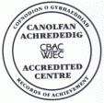

20th January 2017
17th Edition
November
End End

FP ENRICHMENT AFTERNOON
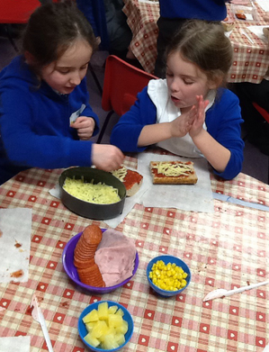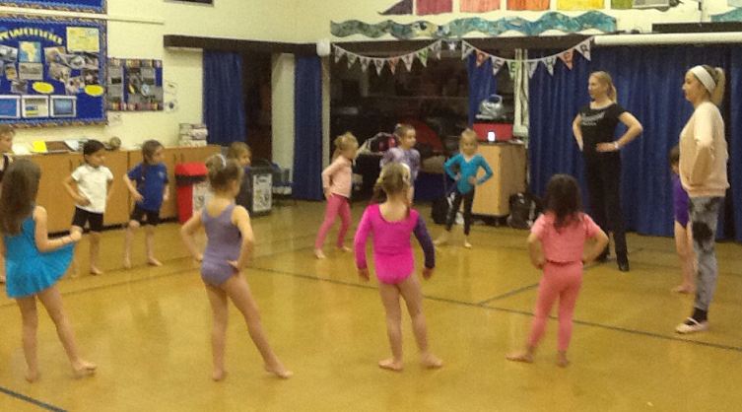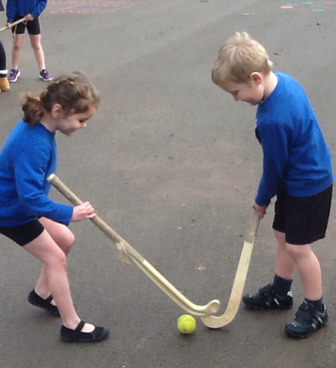
Spring term Enrichment sessions started yesterday - Foundation Phase pupils enjoyed participating in Spanish, Muddy Maths, Masterchef, Horrible Historians, Animation, Groovy Gamers, Dance, Hockey and BEAR Club (Be Enthusiastic About Reading). This term we welcome the support of Mrs Francis-Laing and Miss Caroline who are leading the Dance sessions and the deputy head girl of Chepstow School, Emily Pine-Smith, who is a sharing her expert hockey skills. A good time was had by all!!

FP DELVE & DISCOVER DAY
Today, Foundation Phase children have been introduced to their new topic for this term and have been 'Delving into Dinosaurs'! They arrived in school this morning to find part of the grounds taped off and received a video message from a palaeontologist, Professor Rewaj, who suspected there may be dinosaur bones in our school grounds ... it didn't take the children long before they'd found 12 large bones and numerous smaller bones. They have spent all day investigating dinosaur activities and resources in their classrooms which were transformed overnight! Check out the class bogs over the weekend for photos of their exciting day!!

Y4 SCIENCE LESSON
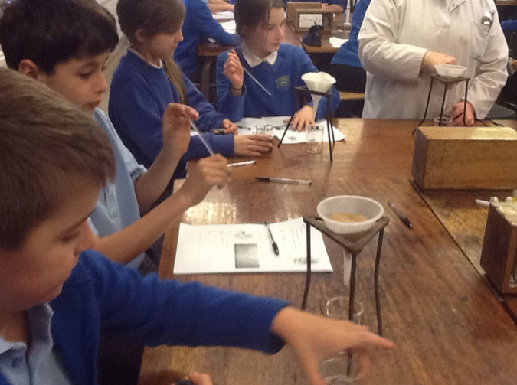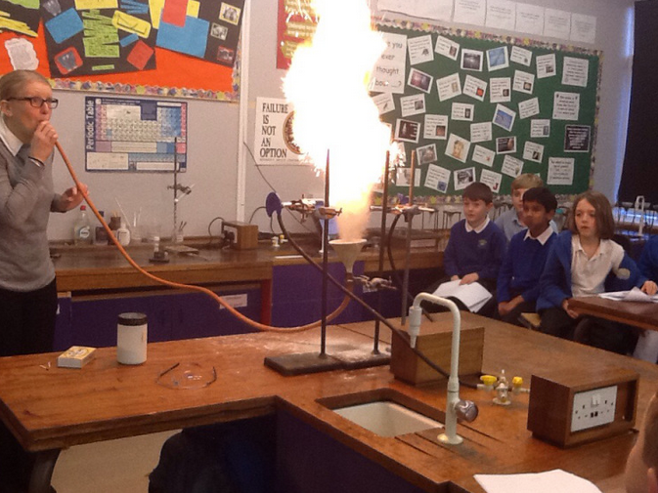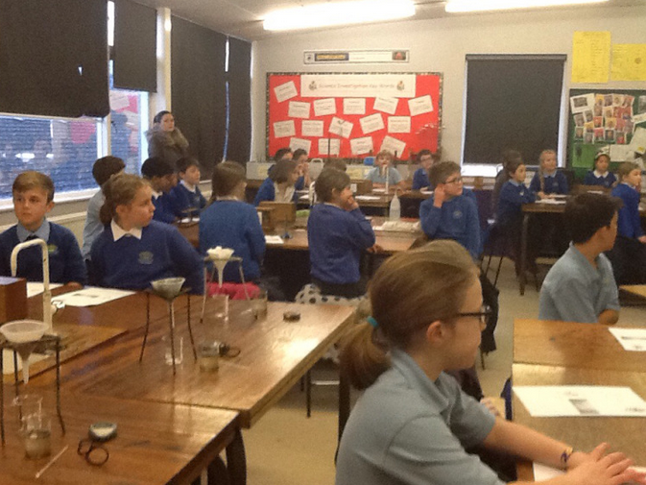
Year 4 enjoyed an afternoon of fun science activities at Chepstow School this week. They learned how Egyptian's measured, investigated what materials filtered water, looked at real sheep's heart and kidney and watched Miss Morris do some crazy experiments!
“I was very ecstatic when we saw the flames go up, Miss Morris blew into a tube which was connected to a funnel of flour, above this were 2 Bunsen burners and the grains of flour caused a MASSIVE flame. She also did an experiment with a jelly baby to show how much energy was in it – she put some stuff in a test tube and a Bunsen burner underneath it and picked up a jelly baby with tweezers and carefully put it into the test tube … it EXPLODED! It was great … fantastic … brilliant and we are really looking forward to science lessons in Comp. Hopefully we can go again soon.”
By Jayden, Frankie & Morgan

RWI WORKSHOP
Huge thank you to Mrs Farley, our Foundation Phase Leader and Read Write Inc Manager, for running a RWI workshop for Reception parents after school this week, enabling the parents to gain a better understanding of how we teach children to read and write and ways they can help at home. We have been using RWI to teach reading and writing skills for about ten years and as a model school frequently welcome teachers and Headteachers from other schools into our lessons to share our excellent practice.

MATHS OPEN MORNING
Hopefully your child brought home today a letter about our Maths open morning which you are invited to on Wednesday 1st February. Please return the slip confirming your attendance and preferred year group asap (by 27th January at the latest!). Many parents ask us what computational strategies we teach so they can support their child at home without confusing them by using methods they were taught in school … this will be an ideal opportunity for you to find out!

SPRING TERM CLUBS
We are pleased to offer the following clubs this term:
Club | Day | Time | Year Groups | Staff
Arts & Crafts | Monday | Lunchtime | Y1 & Y2 | Mrs Farley & Miss Whyte
Just Dance | Monday | Playtime | Y3-Y6 | Mrs Burbidge
Minecraft | Monday | 3.30-4.30 | Y2-Y6 | Mi Little Pad staff
FP Choir | Tuesday | Lunchtime | Y1 & Y2 | Mrs H Stephens
KS2 Choir | Tuesday | Lunchtime | Y3-Y6 | Mrs McDonald
Code Club | Tuesday | Lunchtime | Y3 & Y4 + Digital Leaders | Mr Ledville-Smith
Chess | Wednesday | Lunchtime | Y3-Y6 | Mrs Buchan
French | Wednesday | Lunchtime | Y1 & Y2 - FULL | Club Bonjour
Minecraft | Wednesday | 3.30-4.30 | Y2-Y6 | Mi Little Pad staff
French | Thursday | 3.30-4.30 | Y3-Y6 | Club Bonjour
Table Tennis | Friday | Lunchtime | Y3-Y6 | Sports Council
Please Note: Attribute Sports Clubs will start up again after the half term holiday

HEADTEACHER AWARDS
Last week in Y1, Elisabeth & James worked hard to earn themselves a HT certificate.
This week's head teacher certificates were awarded to:
Rec | Y1 | Y2 | Y3 | Y4 | Y5 | Y6
Anwen, Annie & Hugo | Ffion, Aiden & Euan | Ella, Oliver & Alexander | Caitlin, Evie & Albert | Jayden, Roshan & Matilda | Alfie, Lily & Bobby | Caleb, Harry & Seren J
By
Mrs Jill Mitchell
JillianMitchell@monmouthshire.gov.uk

PTA NEWS
The children are busy doing self-portraits to be put onto a Shirenewton School tea towel. The towels measure approximately 79cm by 51cm and are 100% premium cotton. The PTA is selling them for £4 each to raise money for the school. Order Slips should have come home in book bags this week.
If you haven't yet received an order form, they can be picked up from the school office.
Don't forget, if you want to be a ‘friend of the PTA’ please send your email address to r.dalton1976@outlook.com and we can keep you in mind for our upcoming events.

SPRING TERM DATES
Please note: New dates in red to help you spot them!
Mon 23rd Jan - Hearing retests for selected Rec pupils  Thu 26th Jan - Y6 Football match Vs Eveswell at Shirenewton  Thu 26th Jan - FP Enrichment Afternoon  Mon 30th Jan - Governors' Meeting  Wed 1st Feb - Open Morning for parents (Maths)  Thu 2nd Feb - FP Enrichment Afternoon  Mon 6th Feb - PTA meeting 6.30pm  Mon 6th Feb to Fri 10th Feb - Safer Internet Week  Tue 7th Feb - Y5 & Y6 Digital Leaders > workshop trip  Thu 9th Feb - FP Enrichment Afternoon  Fri 10th Feb - Football Final at Caldicot Leisure Centre  Mon 13th Feb - Welsh Fortnight starts  Mon 13th Feb - Curriculum Cymraeg Workshops all day  Tue 14th Feb to Fri 17th Feb - Y6 to Gilwern  * * *  Mon 20th Feb to Fri 24th Feb - Half Term  * * * | Wed 1st Mar - St David's Day Eisteddfod  Fri 3rd Mar - Welsh Fortnight ends  Mon 6th Mar - Y4 trip to Hilston Park  Tue 7th Mar - Wildlife Quiz 1st Round (4 x Y6 pupils)  Wed 8th Mar - Parents Evening 4-7pm  Thu 9th Mar - Parents Evening 4-7pm  Fri 10th Mar - Eisteddfod Coffee Morning 9.15am  Tue 21st Mar - Wildlife Quiz 2nd Round  Fri 24th Mar - Red Nose day  Mon 27th Mar - Governors' Meeting  Fri 31st Mar - KS2 Enrichment Day  Tue 4th Apr - Y3 trip to Gilwern  Wed 5th Apr - Easter Assembly 9.30am - Y1 & Y4 parents are invited  Fri 7th Apr - Last day of Spring Term  Mon 10th Apr to Fri 21st Apr - Easter Holiday

COMMUNITY CORNER


Single Parent Group
Message from Domini Barnes (Founder of Abergavenny Single Parents Group): "I run a group for single parents with their children. I generally run these sessions during term time – weekly at Abergavenny Community Centre apart from the once per month. I have just opened a session at Bulwark Community Centre. Please see dates below. All single parents are welcome."
Bulwark Community Centre Sundays between 2 – 4pm
15th Jan – 12th Feb – 12th March – 11th June – 16th July – 10th September – 15th October – 12th November
Abergavenny Community Centre – Sundays between 2 – 4pm
January – 22nd & 29th; February – 5th; March – 5th 19th & 26th; April – 2nd; May – 7th – 14th & 24th; June – 18th & 25th; July – 2nd & 9th; August – NO SESSIONS; September – 17th & 24th; October – 1st 8th & 22nd; November – 19th & 26th; December – 3rd & 10th

