 “Learning Together, Achieving for Life”
Weekly Newsletter
www.shirenewton.monmouthshire.sch.uk NUT FREE SCHOOL

"Dysgu Gyda'n Gilydd, Cyflawni am Oes"

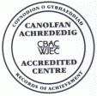

31st March 2017
26th Edition
November
End End

QUIZ AND CAR WASH

"On Thursday the 6th of April year 5 are running a Quiz and Car wash from 5:00 with the quiz starting at 5:30pm.
The car wash is £3.50 per car and is payable on the roundabout when you come into school on the day.
The Quiz is £1 per adult and 50p per child with a maximum of 10 per team with no more than 6 adults.
Food is available from 5pm from the fish and chip van. Order forms are available from Year 5. During the quiz cakes, sweets and drinks are also available.
There will be a chill room (to include a film, games and colouring) available for younger children, from the age of 3, throughout the running of the quiz.
There will also be a raffle for £1 a ticket!
We hope you can join us for this amazing night"
By Year 5

TAG RUGBY TOURNAMENT
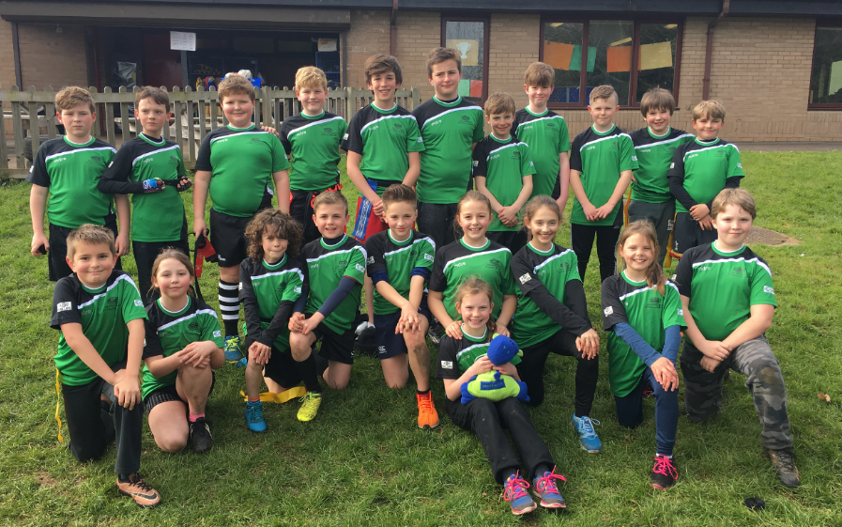
Our Tag Rugby teams thoroughly enjoyed their first ever Tag Rugby Tournament against fellow cluster schools this week. They came a very credible second behind a very impressive St Mary's who were the overall winners. Thank you to Mrs Humphreys for accompanying them and to Owen for coaching them over the last few weeks and giving up his lunch break on a Friday so they can get in a bit of extra practice ... all their hard work certainly paid off!
RED NOSE DAY
Thank you to everyone who supported Comic Relief last Friday by wearing something red and coming to school with 'mad hair' ... we raised a fantastic £225.60.

KS2 CHOIR
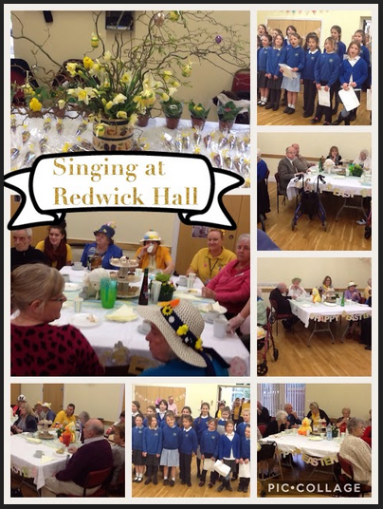
"We went to the care home in Redwick. We were greeted at the door and went into the hall. Everyone had Easter hats on and some were dressed as Easter bunnies! We got into our places and entertained them with 'Wouldn't it be funny?', 'Everywhere around me', 'Donkey tale' and of course our favourite 'Chocolate' song. Once we'd sung all the songs we went around and had a good chat to all the people. Jo, Cai's mum, gave us all a chocolate bunny. We thought it was a great experience; everyone was very, very friendly and it was our pleasure to meet and chat to them. We really enjoyed it and hope they did too." Thank you to Mrs Buchan for leading the Junior choir this term.
By Eleanor and Kate (Y4)

HEALTHY SCHOOLS COMMITTEE
The Healthy Schools Committee gave a confident and informative presentation to governors on Monday evening celebrating our impressive achievement of being the very first school in Monmouthshire to achieve the Welsh Network of Healthy School Schemes National Quality Award.
Please note they have changed the date of the TOOTY-FRUITY 'unusual fruits' tasting day they are organising to ... Wednesday 26th April as their previously advertised date clashed with a theatre trip!

Y3 & Y4 OUTDOOR PROJECT
Year 3 and Year 4 have secured funding and are embarking on an exciting research project looking into whether an increased amount of time learning in the outdoors has any effect on well-being. Next week, they will fill in an online questionnaire measuring "Pupils Attitudes to School & Self" and have an introductory outdoor session on Friday. After the Easter holiday, they will then spend at least 20% of their timetable doing outdoor learning for 10 weeks; at the end of this period they will redo the survey to see how their well-being has changed. Mrs Burgham and Mrs Buchan will send out any additional information that you will need (e.g. what clothes they should wear) nearer the time.

WELSH CHAMPION
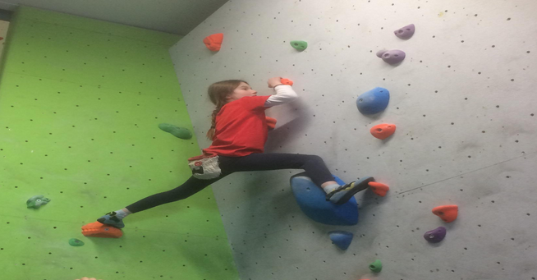
We've been following Holly's climbing success over the last few months and were delighted to hear after her previous 1st place wins and her 2nd place in the competition this weekend she has been crowned the overall BMC Welsh Champion for 2017. Bendigedig Holly! We are very proud of you!

SCHOOL DINNERS
The new Summer menu, starting after the Easter Holidays ...
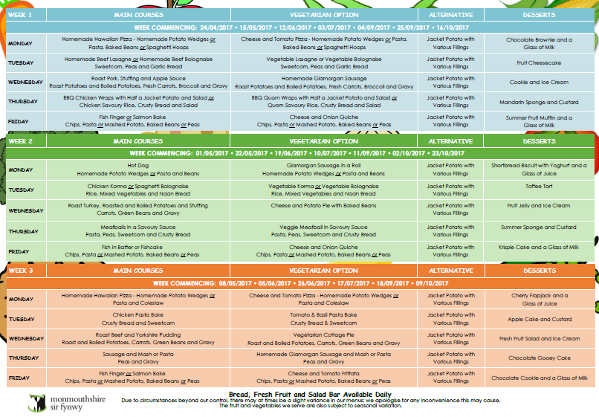

GOLDEN TICKET WINNERS
Last week's lucky golden tickets winners:
Rec | Y1 | Y2 | Y3 | Y4 | Y5 | Y6
Antony, Annie & Lewis | Euan, Arjun & Maya | Demi, Chloe & Tobias | Ben. Dylan H & Jessica | Emily, Eleanor & Oscar | George C, Hannah & Jasmine | Brynn & Joe

By
Mrs Jill Mitchell
JillianMitchell@monmouthshire.gov.uk
THE FINAL WEEK - SPRING TERM
New events in red
Tue 4th Apr - Y3 trip to Gilwern  Wed 5th Apr - Easter Assembly 9.30am - Y1 & Y4 parents are invited  Thu 6th Apr - PTA egg rolling | Thu 6th Apr - Y5 enterprise event - quiz & car wash  Fri 7th Apr - Y3 & Y4 Outdoor learning project  Fri 7th Apr - Last day of Spring Term  Mon 10th Apr to Fri 21st Apr - Easter Holiday

SUMMER TERM
For reminders, please download the Schoop app to your iPhone, iPad or Android device and enter our
school's unique ID - 10134
Mon 24th Apr - Back to school  Mon 24th Apr - KS2 trip to beach  Tue 25th Apr - FP trip to Caldicot Castle  Tue 25th Apr - Y3 & Y4 Outdoor project  Wed 26th Apr - Healthy Schools Tooty Fruity day  Wed 26th Apr - Y4 Forest School  Thur 27th Apr - Y3 & Y4 Outdoor project  Fri 28th Apr - Y2, Y3 & Y4 ballet & museum trip  Mon 1st May - May Day  Tue 2nd May - Y1 Forest School  Tue 2nd May - Y3 & Y4 Outdoor project  Tue 2nd May - Reception Parents Evening 4-7pm  Wed 3rd May - National Reading Tests Y2 - Y6  Wed 3rd May - Y4 Forest School  Wed 3rd May - Reception Parents Evening 4-7pm  Thu 4th May - National Procedural Tests for Y2 - Y6  Thu 4th May - FP Enrichment Afternoon  Thu 4th May - Y3 & Y4 Outdoor project  Fri 5th May - National Reasoning Tests for Y2 - Y5  Fri 5th May - PTA Family Bingo & fish and chips night!  Tue 9th May - National Reasoning Test for Y6  Tue 9th May - Y1 Forest School  Tue 9th May - Y3 & Y4 Outdoor project  Wed 10th May - Y5 Kwik Cricket Festival, Caldicot Castle  Wed 10th May - Y4 Forest School  Thu 11th May - FP Enrichment Afternoon  Thu 11th May - Y3 & Y4 Outdoor project  Tue 16th May - Y1 Forest School  Tue 16th May - Y3 & Y4 Outdoor project  Thu 18th May - FP Enrichment Afternoon  Thu 18th May - Y3 & Y4 Outdoor project  Fri 19th May - Wheelchair sports for Rec & Y1 - Y4  Mon 22nd May - Y2 Forest School  Tue 23rd May - Y1 Camp Fire  Tue 23rd May - Y3 & Y4 Outdoor project  Thu 25th May - FP Enrichment Afternoon  Thu 25th May - Y3 & Y4 Outdoor project  Thu 25th May - PTA Discos  * * *  Mon 29th May to Fri 2nd Jun - Half Term  * * * | Mon 5th Jun - Y2 Forest School  Tue 6th Jun - Y3 & Y4 Outdoor project  Wed 7th Jun - WAG Education Officer visiting School Council  Thu 8th Jun - Y3 & Y4 Outdoor project  Fri 9th Jun - Sports Day (KS2 at 9.15am & FP at 1.45pm)  Mon 12th Jun - Growth & Vision tests for Reception  Mon 12th Jun - Y2 Forest School  Tue 13th Jun - Y3 & Y4 Outdoor project  Wed 14th Jun - Reserve Sports Day  Wed 14th Jun - New Reception parents meeting 6pm  Thu 15th Jun - Y3 & Y4 Outdoor project  Sat 17th Jun - PTA Summer Fayre  Mon 19th Jun - Governors' AGM Meeting (inc Sports Council presentation)  Mon 19th Jun - Y2 Forest School  Tue 20th Jun - Y3 & Y4 Outdoor project  Wed 21st Jun - School Council trip to Senedd, Cardiff Bay  Thu 22nd Jun - Y3 & Y4 Outdoor project  Fri 23rd Jun - Reserve, Reserve Sports Day  Tue 27th Jun - Y3 & Y4 Outdoor project  Thu 29th Jun - Y3 & Y4 Outdoor project  Mon 3rd Jul - INSET (Self Evaluation with Govs)  Mon 3rd July to Friday 14th July - Transition Fortnight  Tue 4th Jul - Y3 & Y4 Outdoor project  Thu 6th Jul - Fire Safety talk for Y4 - Y6  Thu 6th Jul - Y3 & Y4 Outdoor project  Fri 7th Jul - Le Grande Pique-Nique at Chepstow Castle for Y6  Fri 7th Jul - Reports to go home  Fri 7th Jul - Hog Roast  Mon 10th Jul - Pupil Committee Elections  Tue 11th Jul - New Reception visit pm & lunch  Wed 12th Jul - Open Afternoon 2pm  Wed 12th Jul - Parents Evening for those that request it 4pm - 5.30pm  Wed 12th Jul - Music Event 6pm  Thu 13th Jul - New Reception visit pm & lunch  Wed 19th Jul - Y2 Graduation (Y2 parents) 9.30am  Thu 20th Jul - Y6 Leavers' Assembly  Fri 21st Jul - Last day of academic year
ADVANCE NOTICE 2017/18
Mon 4th Sept - INSET Day
Tue 5th Sept - Back to school for pupils
Fri 27th Oct - INSET Day
Mon 30th Oct to Fri 3rd Nov - Half term
Fri 22nd Dec - Last day term
Mon 25th Dec to Fri 5th Jan - Christmas holiday
Mon 8th Jan - Back to school
Mon 19th Feb to Fri 23rd Feb - Half term
Thu 29th Mar - Last day
Fri 30th Mar to Fri 13th Apr - Easter holiday
Mon 16th Apr - Back to school
Mon 7th May - May Day
Mon 28th to Fri 1st Jun - Half term
Tue 24th Jul - Last day

PTA NEWS
PTA dates for your diary:
Wednesday 5th April - Easter Assembly for parents of year 1 and 4. Refreshments will be available from the PTA from 9am with assembly starting at 9.30am
Thursday 6th April - Egg Rolling Tournament ... decorated hard boiled chicken eggs only!! Plus £1 to enter. Special guest: The Easter bunny!
Friday 5th May - Family Bingo Fun and fish and chips night!

COMMUNITY CORNER
On 20th April, as part of the Chepstow Walking Festival, there is a family friendly walk at Chepstow racecourse. This event includes an exclusive walk around the inside track of the course with pictures to find along the way. All children participating will receive a certificate and a snack. Tesco Chepstow are providing some lovely fruits for the children to try once they have completed the walk. Adults can enjoy hot drinks and snacks from the cafe in the racecourse building that will be open on the day. This is a FREE event and no booking necessary but please let me know you are coming so that we have enough to certificates. You can find more details and click whether you're coming to the link below.
https://www.facebook.com/events/1669737273319528/?ti=icl