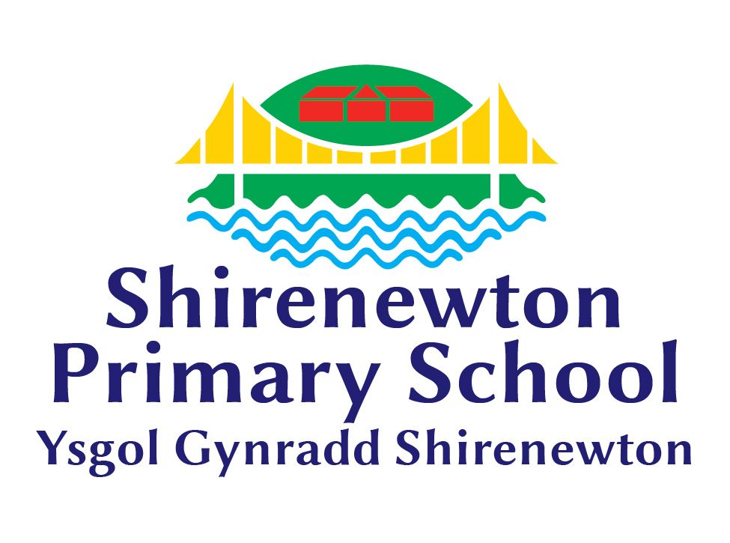 “Learning Together, Achieving for Life”
Weekly Newsletter
www.shirenewton.monmouthshire.sch.uk NUT FREE SCHOOL

"Dysgu Gyda'n Gilydd, Cyflawni am Oes"

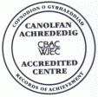

10th February 2017
20th Edition
November
End End

HELP NEEDED!

We are in the process of purchasing a massive wooden chalet which will be used as an additional teaching space for groups of Read Write Inc and maths learners, music lessons, a cosy cwtsh nurture room and a variety of other uses! It will be positioned on the piece of flat ground where the poly tunnel and willow caterpillar are currently sited. If you are able to spare a few hours during the half term holiday to help us move the poly tunnel, vegetable beds and dig up the willow structure please email me asap:
JillianMitchell@monmonthshire.gov.uk
We are hoping the chalet will be constructed late Spring/early Summer and would like to prepare the site during this holiday.

GYM STAR
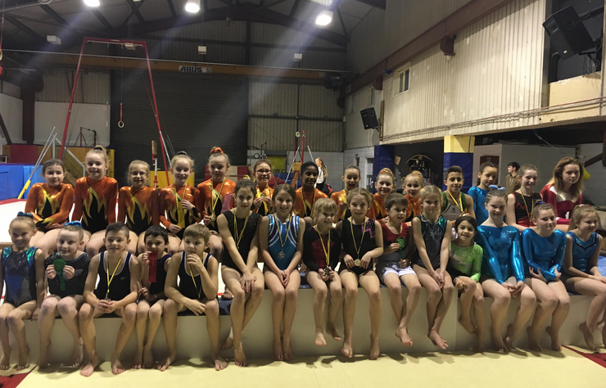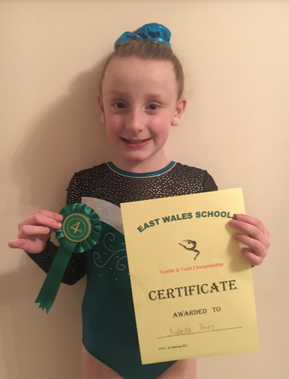
Huge congratulations to Issy in Year 5 who represented the school in the East Wales Schools Tumble and Vault Championships last Friday. We are very proud of her gymnastics talent, she came a very credible 4th place and will now represent the region at the Welsh finals in Cardiff next month.
"Last Friday I went to a gymnastics competition representing the school and we did tumbles and vaults . I was against 4 other schools and about 30 gymnasts altogether. In my vaults I did squat through and straddle. In my tumble I did cartwheels, roundoffs, back flicks and jumps. I'm looking forward to the Welsh finals. "
By Issy

DIGITAL LEADERS TRIP
"We got to The Eden Centre 15 minutes before the other schools. We went into a Lego workshop room which had ipads and a big box of Lego. We watched a video and then made electric Lego space rovers. We had to connect cables and program it from our i-pad; we could move other people's robots as well as our own! Then it was snack time. After that, we went into the hall and started using google cardboard VR (that stands for virtual reality). We put an i-pod into the front of the google cardboard and you hold it over your eyes. Our first stop was New York - it was amazing if you looked up you could see the sky, down was the ground, and if you looked side to side you could see around the city. After New York, we went to Mars and then into out of space. This guy had designed his own Minecraft world and we got to look around that too. Then we discovered some apps e.g. Morgan went on a rollercoaster which felt like a real one. That made us think we'd like to have a VR club in school!! After lunch we played football in the softplay and had a quiz. Finally, we went on Hwb, it was hosted by Ty Isaf Infants, Risca - we used Jit5 and J2E. We also discovered programming - using Stop Start Animation we could move the character on the laptop. After that, we painted our own internet safety emojis but unfortunately we had to leave before the winners were announced. We really enjoyed our experience at The Eden Education centre and we're sure next year's Digital Leaders will LOVE IT as much as we did. We really want to thank Mr Ledville-Smith for taking us on a fantastic trip."
By Harry, Katie, Morgan & Sorcha

YEAR 5 TRIP
"On Tuesday we went to Cardiff for a school trip to St David's Hall to watch Orchestra Adventure. We got there early so we had lunch outside on the statue and we went in and walked up lots of flights of stairs. Then we went in the quiet room and did our 'vlogs' (video blog) and we did that for 45 minutes and then when the other schools arrived we went into the arena and after waiting for 10 minutes it started. We were introduced to the different sections of the orchestra e.g. brass, strings etc. A chap called Tom introduced the stories of where the songs came from. He introduced us to the conductor and explained how you do conducting. They played 'Star Wars, the Force Awakens', 'Beethoven's Symphony No. 5', 'Stravinsky's Infernal Dance' and 'Grieg's In the Hall of the Mountain King' plus lots more. We thought it was a good trip; at first we weren't quite surely if we'd enjoy it BUT it turned out to be really good the way they did it all so fast. It's inspired us to want to be a conductor!
By Maddy and Tom

SAFER INTERNET WEEK
Throughout the week, all classes have been learning the importance of staying safe online. It was Safer Internet Day on Tuesday but we extended this to a Safer Internet Week instead. Every class has completed various activities and the learning has been shared on class blogs. In this day and age, it is imperative we ensure all children understand the dangers of the internet and online platforms and become digitally safe and competent.

SCHOOL COUNCIL
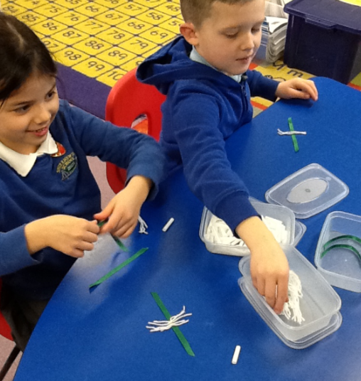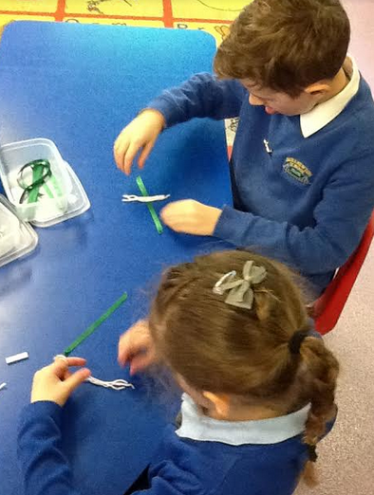
School Council have been busy making leeks this week to sell to raise money for the British Heart Foundation. These leeks will be on sale to parents and visitors in the foyer next week and pupils can buy one on St David's Day ... more details to follow.

CAERWENT COMMUNITY COUNCIL COMPETITION
Key Stage 2 classes enjoyed entering the yearly Caerwent Community Council competition, which had an Olympic theme this year. Every year Caerwent Community Council very kindly donate £120; with the money this year we bought Amazon vouchers for the winners. Year 3 designed a Paralympics mascot; Year 4 designed a new Olympic medal; Year 5 wrote biographies about Welsh Paralympians and Year 6 made powerpoints about Welsh Olympians.
Mrs Haddow, the Chair of the community council, judged the competition and the winners were:

 | Year 3 | Year 4 | Year 5 | Year 6
1st (£15) | Anjali & Ella W | Eleanor | Conor & Archie | Bethan
2nd (£10) | Grace | Katie | Alfie & George | Lloyd
3rd (£5) | Thomas | Kate | Jasmine & Ella | Seren S & Jemima

CHANGE OF MENU
First week back after half term, we have a change of menu on the Tuesday and Wednesday. On Tuesday 28th February, the canteen will be cooking the roast dinner that was due to be served on the Wednesday, as on the Wednesday they will cooking a special St David's day menu ...

HEADTEACHER AWARDS
This week's head teacher certificates were awarded to:
Rec | Y1 | Y2 | Y3 | Y4 | Y5 | Y6
Daisy, Philip & Emilia | Jessica, James & Bea | Laila, Aemilia & Barnaby | Jessica, Juniper & Sienna | Alfie, Brecon & Daniel | Ben, Will & Flora | Isabella, Dylan & Joe

GOLDEN TICKET WINNERS
Lucky golden tickets winners this week were:
Rec | Y1 | Y2 | Y3 | Y4 | Y5 | Y6
Hugo, Evie C & Daisy | Laci, Bea & Annabel | Madison, Niamh & Floelyn | Charlie,  Ella W & Caitlin | Barny, Roshan & Jack | Gethin, Walt & Issy | Daniel, Ben & Caleb

By
Mrs Jill Mitchell
JillianMitchell@monmouthshire.gov.uk

PTA NEWS
Friday, 3rd March, 2017. Shirenewton Primary School. Fashion Show & Shopping Night
7:00pm - Doors & Stalls Open
7:30pm - Love Labels Fashion Show Starts
8:15pm - Raffle followed by a Love Labels Clothes Sale
1st prize for the raffle is a £50 voucher for Love Labels. Clothes sale will include top high street brands at greatly reduced prices. Sizes range from 8-22 for ladies and 2-14 years for children (boys and girls).
Tea, coffee, soft drinks and cream cakes will be available to purchase, plus a licensed bar.
Tickets are £4 each or 3 tickets for £10.
All adult tickets will include a glass of fizz (non alcoholic will be available).
Children need a ticket but go free with a paying adult.
If you would like to take part in the fashion show, please indicate on the slip below.

------------------------------------------------------------------------------------------------------------------
Name ________________________________________________
I would like to purchase _____ adult tickets for the fashion show. I would also like _____ child tickets.
I enclose £_____(£4 per adult ticket or 3 tickets for £10). Please make cheques payable to 'Shirenewton PTA'.
I would like to take part in the fashion show YES / NO

SPRING TERM DATES
Please note: Any new dates are in red
For reminders, please download the 'Schoop' app to your iPhone, iPad or Android device and enter our
school's unique ID - 10134
Mon 13th Feb - Welsh Fortnight starts  Mon 13th Feb - Curriculum Cymraeg Workshops all day  Wk Beg 13th Feb - Year 3 parents evenings  Wed 15th Feb - Dinosaur experience day (PTA funded)  Tue 14th Feb to Fri 17th Feb - Y6 to Gilwern  * * *  Mon 20th Feb to Fri 24th Feb - Half Term  * * *  Wed 1st Mar - St David's Day Eisteddfod  Fri 3rd Mar - Welsh Fortnight ends  Fri 3rd Mar - PTA Ladies Night  Mon 6th Mar - Y4 trip to Hilston Park  Mon 6th Mar - PTA meeting  Tue 7th Mar - Wildlife Quiz 1st Round (4 x Y6 pupils)  Wed 8th Mar - Parents Evening 4-7pm  Thur 9th Mar - KS2 Egyptian Museum Day 2.30pm (Y3-6 parents invited) | Thu 9th Mar - Parents Evening 4-7pm  Fri 10th Mar - Eisteddfod Coffee Morning 9.15am  Thu 16th Mar - Techniquest Workshops (at school):  - Rec - Y3 = Techniquest Maths Party  - Y3 - Y6 = Science Bright Sparks Experience  Tue 21st Mar - Wildlife Quiz 2nd Round  Fri 24th Mar - Red Nose day  Mon 27th Mar - Governors' Meeting  Fri 31st Mar - KS2 Enrichment Day  Tue 4th Apr - Y3 trip to Gilwern  Wed 5th Apr - Easter Assembly 9.30am - Y1 & Y4 parents are invited  Thu 6th Apr - PTA egg rolling  Fri 7th Apr - Readathon starts (more info to follow)  Fri 7th Apr - Last day of Spring Term  Mon 10th Apr to Fri 21st Apr - Easter Holiday

