 “Learning Together, Achieving for Life”
Weekly Newsletter
www.shirenewton.monmouthshire.sch.uk NUT FREE SCHOOL

"Dysgu Gyda'n Gilydd, Cyflawni am Oes"

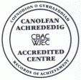

27th January 2017
18th Edition
November
End End

FOOTBALL MATCH
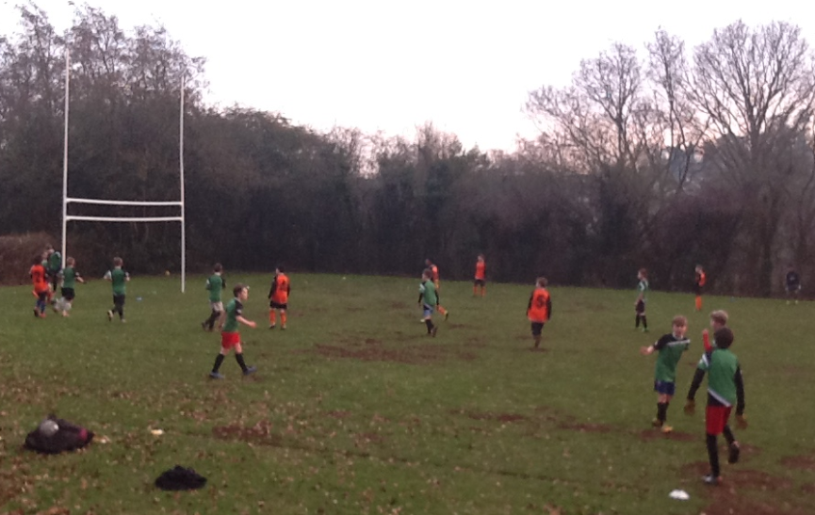
Yesterday, Owen (our Attribute Sports coach who teaches Key Stage 2 PE) organised football matches for Year 6 against Eveswell Primary School - there was a boys team and a girls team. Check out the class blog next week to read the match reports.

HOMEMAKERS
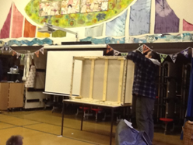
"On Tuesday we had a visit from a company called 'Homemakers' who came into our assembly and talked us through the recycling process of a bed! It was really interesting to see how they took the bed apart so all the different parts could be recycled. They also recycle books, DVDs, metal and much more! They aim to recycle 100% 0f British rubbish. They also aim to reduce landfill. For more info: www.hmcrecycling.co.uk "
By the Eco Committee

MATHS OPEN MORNING
Today is the final day for letting us know if you will be attending our Maths opening morning next week as staff need time to organise groupings and activities for the lesson. Please return the slip at the bottom of the open morning letter or drop us an email today if you want to join us in maths lessons on Wednesday and learn about our maths teaching strategies.
Did you know? Schools are open to pupils 190 days of the year which allows 175 non-school days for holidays, rest and non-urgent appointments!
ATTENDANCE



Our attendance target for this academic year is 96.5%. Unfortunately, in the Autumn term we attained an attendance figure of 96%.

Our class attendance H.E.R.Oes (Here Everyday Ready On-time) for the Autumn term were: Year 3
In the Autumn term they achieved a very impressive 99.1%. Year 6 had the next highest attendance rate of 96.5%. Unfortunately, all other classes were below our attendance target.

PEER OBSERVATIONS
I am so proud of our Year 6 School Councillors, Brooke and Joe, who performed a series of peer observations in KS2 Maths Reasoning lessons this week. They were focusing on the 'behaviour for learning' in all four classes. They showed great insight and maturity when sharing their findings with the teacher and children in each class and made useful suggestions to the children about ways they could improve their behaviour for learning.

EASTER HOLIDAY CLUB
Following the hugely successful summer holiday club, Melinda is considering running a holiday club at school during the first week of the Easter holiday ... if there is enough parent interest. Please email Melinda asap if you are interested, letting her know exactly which days your child(ren) would attend so she can make a final decision about whether it's worth organising or not:
melinda.phillips@btinternet.com

HEADTEACHER AWARDS
This week's head teacher certificates were awarded to:
Rec | Y1 | Y2 | Y3 | Y4 | Y5 | Y6
Caden, James & Antony | Laci, Milo S & Martha W | Barney, Cally & Terah | Ben, Grace & Hudson | Seren W, Oliver T & Oliver W | Gethin, Rhianwen & James | William H, Pippa & George N

GOLDEN TICKET WINNERS
Lucky golden tickets winners last week were:
Rec | Y1 | Y2 | Y3 | Y4 | Y5 | Y6
Caden, Seren & Edward | Tomos, Amélie  & Natalie | Cally, Terah & Lauren | Caitlin, Mali & Eloise | Libby, Matilda & Carter | Conor, Flora & Maddy | Lloyd, Immy N & Jemima

By
Mrs Jill Mitchell
JillianMitchell@monmouthshire.gov.uk

PTA NEWS
1) We will be holding the next school disco on:
Thursday 9th February. 3:30-4:30pm Foundation Phase. 4:45-5:45pm KS2.
Anyone wishing to volunteer, please contact Rachel/Sarah at school or via PTA Facebook page.

2) Save the Date - Friday, 3rd March, 2017. 7pm. Shirenewton Primary School Ladies Night
Who wants to join us for a night of entertainment, shopping, prosecco and cream cakes?
Doors open at 7pm where there will be several stalls selling an array of items, plus some fully qualified beauticians doing mini manicures.
Tea, coffee, soft drinks and cream cakes will be available to purchase, plus a licensed bar.
Take your seats at 7.30pm for a fashion show of ladies and children's clothes (modelled by students and volunteers from the school). The show lasts for about 45 minutes, after which you can browse the rails and make purchases. There will be over 1000 items of ladies and children’s clothing to suit all tastes, from top high street brands, with savings up to 50% and even 75% off original store prices. Sizes range from 8-22 for ladies and 2-14 years for children (boys and girls). All come with a 28 day full refund policy.
We will also be selling tickets for a raffle on the night, with the top prize being a £50 voucher to spend on clothes from the fashion show, plus other lovely prizes donated by our stall holders.
We will be selling tickets at £4 each or 3 tickets for £10. All adult tickets will include a glass of fizz (a non alcoholic option will also be available). Tickets available in advance from the school (01291 641774) or contact Shirenewton Primary School PTA via Facebook.

3) Don't forget to order your Shirenewton school tea towels in time for mothers day, please ask Sarah Denne or Rachel Dalton if you need an order form!

4) The next PTA meeting will be Monday 6th February, 6.30pm in the school, all welcome!

5) Don't forget you can leave an email address at r.dalton1976@outlook.com to be put on our list of event volunteers.

SPRING TERM DATES
Please note: New dates in red to help you spot them!
Mon 30th Jan - Governors' Meeting  Wed 1st Feb - Open Morning for parents (Maths)  Thu 2nd Feb - FP Enrichment Afternoon  Mon 6th Feb - PTA meeting 6.30pm  Mon 6th Feb to Fri 10th Feb - Safer Internet Week  Tue 7th Feb - Y5 & Y6 Digital Leaders > workshop trip  Thu 9th Feb - FP Enrichment Afternoon  Thu 9th Feb - PTA Discos  Fri 10th Feb - Football Final at Caldicot Leisure Centre  Mon 13th Feb - Welsh Fortnight starts  Mon 13th Feb - Curriculum Cymraeg Workshops all day  Wed 15th Feb - Dinosaur experience day (PTA funded)  Tue 14th Feb to Fri 17th Feb - Y6 to Gilwern  * * *  Mon 20th Feb to Fri 24th Feb - Half Term  * * *  Wed 1st Mar - St David's Day Eisteddfod  Fri 3rd Mar - Welsh Fortnight ends | Fri 3rd Mar - PTA Ladies Night  Fri 3rd Mar - PTA Shaw Trust collection  Mon 6th Mar - Y4 trip to Hilston Park  Tue 7th Mar - Wildlife Quiz 1st Round (4 x Y6 pupils)  Wed 8th Mar - Parents Evening 4-7pm  Thu 9th Mar - Parents Evening 4-7pm  Fri 10th Mar - Eisteddfod Coffee Morning 9.15am  Tue 21st Mar - Wildlife Quiz 2nd Round  Fri 24th Mar - Red Nose day  Mon 27th Mar - Governors' Meeting  Fri 31st Mar - KS2 Enrichment Day  Tue 4th Apr - Y3 trip to Gilwern  Wed 5th Apr - Easter Assembly 9.30am - Y1 & Y4 parents are invited  Thu 6th Apr - PTA egg rolling  Fri 7th Apr - Last day of Spring Term  Mon 10th Apr to Fri 21st Apr - Easter Holiday

COMMUNITY CORNER
Magor Marsh Activities
Winter Fun Day – Saturday 18th February 1-4pm at Magor Marsh NP26 3DD. Children £2. Adults FREE. We’ll be toasting marshmallows, bird watching and doing willow crafts!

Coastal Path Walk – Magor to Goldcliff – Monday 27th March 11-4pm starting at Magor Marsh. Join our Reserves Officer – Richard Bakere for a good long hike along the coastal path looking at wildlife, wildfowl and waders. Booking essential – Phone Dipti on 01600 740600. GWT members - £10 ; non-members £15.

Spring Fun Day – Saturday 8th April 1-4pm at Magor Marsh NP26 3DD. Children £2. Adults FREE. Pond Dipping, bird watching and springtime crafts.

Marshy Monday – 10th April 1-3pm. Children £2. Adults FREE. Join Petra for some pond dipping and wildlife exploration.

